LIBRARY MANAGEMENT SYSTEM

A project submitted in partial fulfillment of the requirements for the award of 3 years “Diploma in Computer Science and Engineering”



Submitted by: - Under guidance of: -
Kartik Kumar Mr. Pardeep Singh
1935052003 H.O.D. (CSE)

GURU TEGH BAHADUR POLYTECHIC INSTITUTE G-8 AREA, RAJOURI GARDEN, NEW DELHI-110064(AFFILATED TO BOARD OF TECHNICAL EDUCATION & AICTE)

BATCH 2018-2021

DECLARATION

I hereby certify that the work carried out in this project is an authentic record of my own. I hereby submit this project, as approved by my supervisor/ project guide. I have read and understood the rules related to the project, inventions and innovations and agree to be bound by them. I also declare that this work has not been submitted earlier for the award of any degree or diploma to the best of my knowledge and belief.

Kartik Kumar
(VI Semester)

1935052003

Diploma in Computer Science & Engr.

Date: 25-06-2021 GTBPI, G-8 Area,
Rajouri Garden,
N.D-64.

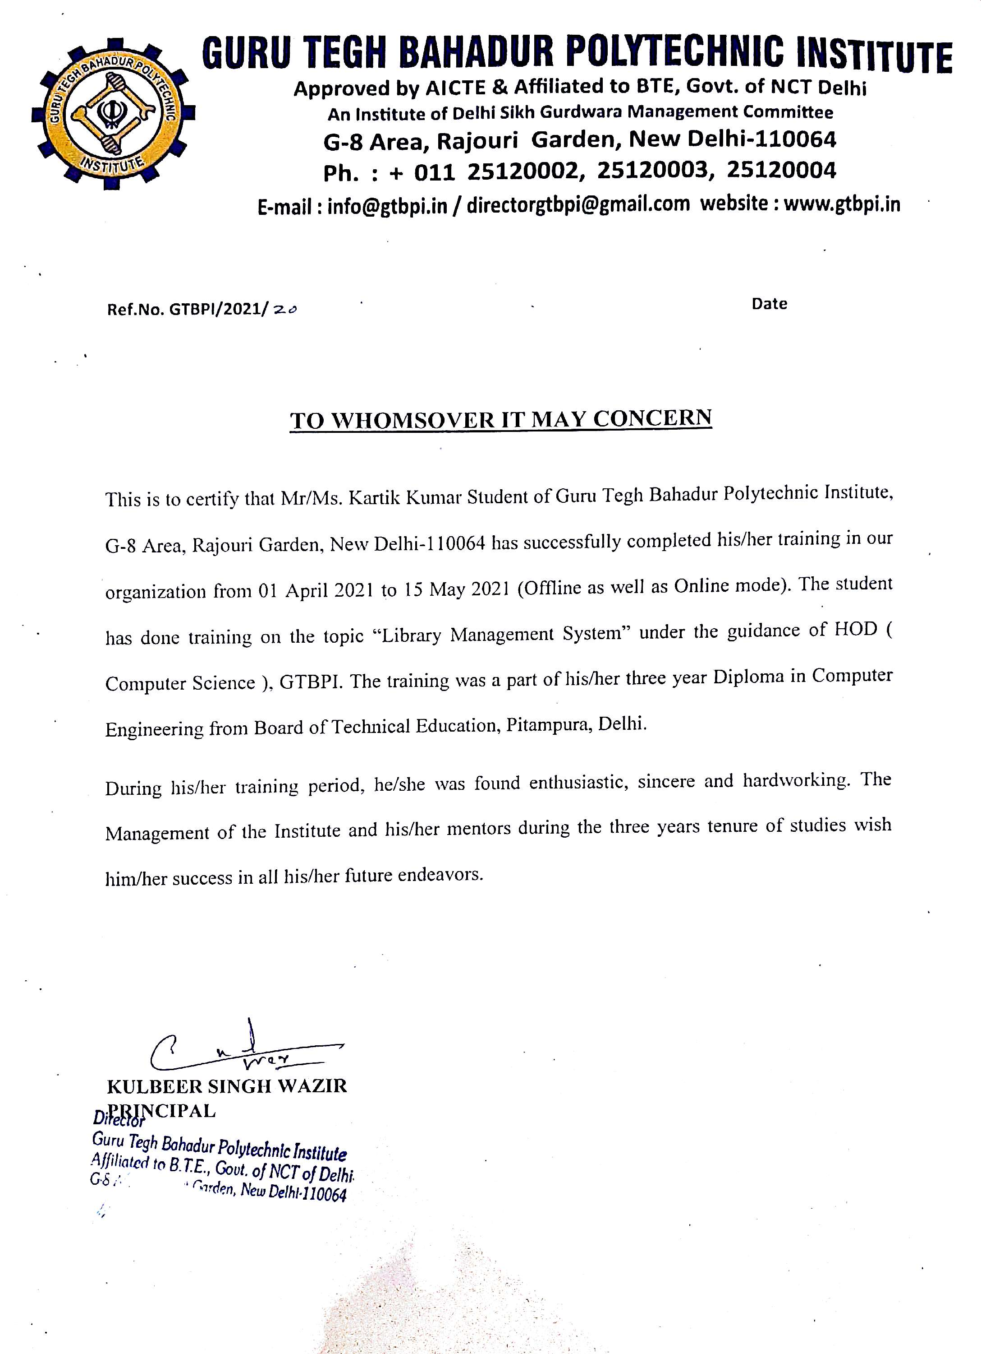
ACKNOWLEDGMENT

I would like to thank all my respected teachers (Mr. Pardeep Singh, Ms. Ritu Gupta, Ms. Bismah Rafiq, Ms. Jaspreet Kaur) for encouraging me and giving me an opportunity to work in the Industry on the project Library Management System. This project Library Management System gave me an opportunity and pleasure to explore new and challenging field and let me achieve maximum out of my project.

I also wish my gratitude to our honorable Principal, GTBPI “S. Kulbeer Singh Wazir” and TPO (Training and placement officer) who helped me at every point and guided me with the right direction to step forward in my career to grab all opportunities during the course of my study in GTBPI from 2018-2021 and to undergo this training.

Table of Contents
S.No. | Topic Title | Page No.
1 | Abstract | 6
2 | Introduction | 7
3 | System analysis | 8-9
4 | System specification | 10
5 | Feasibility study | 11-12
6 | Introduction to design  6.1 Use case diagram  6.2 Data flow diagram  6.3 Entity-Relation diagram | 13-26
7 | Modules | 27
8 | Overview of technologies used | 28-37
9 | Database tables | 38-56
11 | Implementation | 57-62
12 | Testing | 63-66
13 | Output Screen | 67-77
14 | Conclusion | 78
15 | Future scope | 79
16 | Limitation | 80
17 | Bibliography | 81

Abstract
The purpose of Library Management System is to automate the existing manual system by the help of computerized equipment and full-fledged computer software, fulfilling their requirements, so that their valuable data/information can be stored for a longer period with easy accessing and manipulation of the same. The required software and hardware are easily available and easy to work with.
Library Management System, as described above, can lead to error free, secure, reliable and fast management system. It can assist the user to concentrate on their other activities rather to concentrate on the record keeping. Thus it will help organization in better utilization of resources. The organization can maintain computerized records without redundant entries. That means that one need not be distracted by information that is not relevant, while being able to reach the information.
The aim is to automate its existing manual system by the help of computerized equipment and full-fledged computer software, fulfilling their requirements, so that their valuable data/information can be stored for a longer period with easy accessing and manipulation of the same. Basically the project describes how to manage for good performance and better services for the clients.

Introduction

The "Library Management System" has been developed to override the problems prevailing in the practicing manual system. This web application is supported to eliminate and in some cases reduce the hardships faced by this existing system. Moreover, this web application is designed for the particular need of the college library, university library and normal library to carry out operations in a smooth and effective manner.
The web application is reduced as much as possible to avoid errors while entering the data. It also provides error message while entering invalid data. No formal knowledge is needed for the librarian to use this web application. Thus by this all it proves it is user-friendly. Library Management System, as described above, can lead to error free, secure, reliable and fast management system. It can assist the user to concentrate on their other activities rather to concentrate on the record keeping. Thus it will help college library, university library and normal library in better utilization of resources.
Every Library, whether big or small, has challenges to overcome and managing the information of Books, Books Units, Students, Assigned Books, Submitted Books and etc. Every Library Management System has different Student needs. Therefore, we design exclusive student management module that are adapted to your managerial requirements.

System Analysis
Online Library Management System is an Automated Library System that handles the various functions of the library. It provides a complete solution to the library management online. In the existing system, the record is done only manually but in proposed system we have to computerize the exams using this application. Lack of security of data, more man power, Time consuming, consumes large volume of pare work, Needs manual calculations and No direct role for the higher officials.
Using an Online Library Management System has many benefits. Here are some benefits of online library management system over paper-based record which should convince you to start using an online library management system.
1. Up-to-date:
This keeps details of the books, magazines or other materials available in the library as per their categories. The addition or removal of the books is simple as the software updates the records in one fraction.
2. Record Maintenance:
The assigned books details will be stored & maintained, and if students didn’t submit assigned book then you send reminder to that student for submission of book.
3. Get Easy Access:
It is easy to do library audit any time as records are maintained by the highly efficient software and are accessible very easily.

4. Dynamic Reports
It is simple to maximize performance of the libraries with the dynamic r graphs and charts to review or track progress for better decision-making.
5. Free Form Errors
Automated online library management system is powerful, user-friendly, as well as developed for simple entry of the data, makes the library operations totally free from any errors.
6. Completely Customizable
Library management system is completely adaptable and customizable to the needs of the educational institutions for providing fast and reliable data.
7. Improve reporting & monitoring
The self-updating records will give rise to the dynamic reporting & oversight capabilities. This can allow the management of materials in the system as you will come to know what is available books, or what is assigned books.

Features of Library Management System
- Integration of all records of students
- Manage the records systematically
- It can track any information online
- One can generate the reports
- Manage all information online
- Easy to maintain records
- It leads to fast book entry
- Email reminder to students
System Specification
- Software Requirement

Operating System: Linux / Windows / Mac / other.
Programming Language: Java.
Database: Oracle 19c.
Web Server: Tomcat 8.
Browser: Chrome / Safari / Firefox.
Software Development Kit: Java Runtime Environment 8.
Scripting Language Enable: JSP (Java server page).

- Hardware Requirement

Processor: AMD64 or Intel EM64T.
Physical RAM: 2 GB minimum.
Swap (virtual memory): at least the same size as the physical memory (2 GB minimum).
Available disk space: 20 GB (OS excluded).
Video adapter: 256 colours.
Display (screen resolution): 1024 x 768 minimum.

Feasibility Study
After doing the project Library Management System, study and analyzing all the existing or required functionalities of the system, the next task is to do the feasibility study for the project. All projects are feasible - given unlimited resources and infinite time.
Feasibility study includes consideration of all the possible ways to provide a solution to the given problem. The proposed solution should satisfy all the user requirements and should be flexible enough so that future changes can be easily done based on the future upcoming requirements.

Economic Feasibility
This is a very important aspect to be considered while developing a project. We decided the technology based on minimum possible cost factor.
  - All hardware and software cost has to be borne by the organization.
  - Overall we have estimated that the benefits the organization is going to receive from the proposed system will surely overcome the initial costs and the later on running cost for system.

Technical Feasibility
This included the study of function, performance and constraints that may affect the ability to achieve an acceptable system. For this feasibility study, we studied complete functionality to be provided in the system, as described in the System Requirement Specification (SRS), and checked if everything was possible using different type of frontend and backend platforms.
Operational Feasibility
No doubt the proposed system is fully GUI based that is very user friendly and all inputs to be taken all self-explanatory even to a layman. Besides, a proper training has been conducted to let know the essence of the system to the users so that they feel comfortable with new system. As far our study is concerned the clients are comfortable and happy as the system has cut down their loads and doing.

Introduction to design
Design is the first step in the development phase for any techniques and principles for the purpose of defining a device, a process or system in sufficient detail to permit its physical realization.
Once the software requirements have been analyzed and specified the software design involves four technical activities - design, coding, implementation and testing that are required to build and verify the software.
The design activities are of main importance in this phase, because in this activity, decisions ultimately affecting the success of the software implementation and its ease of maintenance are made. These decisions have the final bearing upon reliability and maintainability of the system. Design is the only way to accurately translate the customer’s requirements into finished software or a system.
Design is the place where quality is fostered in development. Software design is a process through which requirements are translated into a representation of software. Software design is conducted in two steps. Preliminary design is concerned with the transformation of requirements into data.
6.1 Use Case Diagram
In the Unified Modelling Language (UML), a use case diagram can summarize the details of your system's users (also known as actors) and their interactions with the system. To build one, you'll use a set of specialized symbols and connectors. An effective use case diagram can help your team discuss and represent:
- Scenarios in which your system or application interacts with people, organizations, or external systems.
- Goals that your system or application helps those entities (known as actors) achieve.
- The scope of your system.
A use case diagram doesn't go into a lot of detail—for example, don't expect it to model the order in which steps are performed. Instead, a proper use case diagram depicts a high-level overview of the relationship between use cases, actors, and systems. Experts recommend that use case diagrams be used to supplement a more descriptive textual use case.
6.1.1 Use Case Component
Actor:
A coherent set of roles that users of use cases play when interacting with the use cases.


Use case:
A description of sequence of actions, including variants, that a system performs that yields an observable result of value of an actor.


System boundary boxes:
A box that sets a system scope to use cases. All use cases outside the box would be considered outside the scope of that system. For example, Psycho Killer is outside the scope of occupations in the chainsaw example found below.

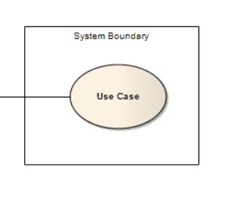
Associations:
A line between actors and use cases. In complex diagrams, it is important to know which actors are associated with which use cases.

Relationship:
There are two type of relationship in use case diagram. It is also stereotype. One is implicit function and second one is explicit function.

6.1.2 Library Management Use Case Diagram
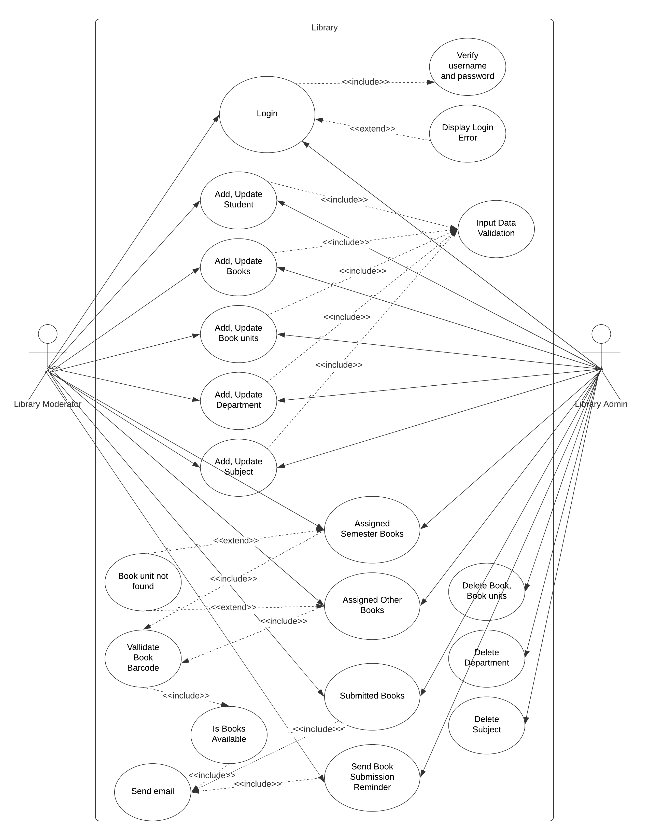
Figure 1
6.2 Data Flow Diagrams
The DFD takes an input-process-output view of a system i.e. data objects flow into the software, are transformed by processing elements, and resultant data objects flow out of the software.
Data objects represented by labeled arrows and transformation are represented by circles also called as bubbles. DFD is presented in a hierarchical fashion i.e. the first data flow model represents the system as a whole. Subsequent DFD refine the context diagram (level 0 DFD), providing increasing details with each subsequent level.
The DFD enables the software engineer to develop models of the information domain & functional domain at the same time. As the DFD is refined into greater levels of details, the analyst performs an implicit functional decomposition of the system. At the same time, the DFD refinement results in a corresponding refinement of the data as it moves through the process that embody the applications.
A context-level DFD for the system the primary external entities produce information for use by the system and consume information generated by the system. The labeled arrow represents data objects or object hierarchy.
6.2.1 Rules for DFD:
- Fix the scope of the system by means of context diagrams.

- Organize the DFD so that the main sequence of the actions

- Reads left to right and top to bottom.

- Identify all inputs and outputs.

- Identify and label each process internal to the system with Rounded circles.

- A process is required for all the data transformation and Transfers. Therefore, never connect a data store to a data Source or the destinations or another data store with just a Data flow arrow.

- Do not indicate hardware and ignore control information.

- Make sure the names of the processes accurately convey everything.

6.2.2 Components of DFD
All data flow diagrams include four main elements: entity, process, data store and data flow.
External Entity:
Also known as actors, sources or sinks, and terminators, external entities produce and consume data that flows between the entity and the system being diagrammed. These data flows are the inputs and outputs of the DFD. Since they are external to the system being analyzed, these entities are typically placed at the boundaries of the diagram. They can represent another system or indicate a subsystem.

Process:
An activity that changes or transforms data flows. Since they transform incoming data to outgoing data, all processes must have inputs and outputs on a DFD. This symbol is given a simple name based on its function, such as “Ship Order,” rather than being labeled “process” on a diagram. In Gane-Sarson notation, a rectangular box is used and may be labeled with a reference number, location of where in the system the process occurs and a short title that describes its function. Processes are typically oriented from top to bottom and left to right on a data flow diagram.

Data Store:
A data store does not generate any operations but simply holds data for later access. Data stores could consist of files held long term or a batch of documents stored briefly while they wait to be processed. Input flows to a data store include information or operations that change the stored data. Output flows would be data retrieved from the store.

Data Flow:
Movement of data between external entities, processes and data stores is represented with an arrow symbol, which indicates the direction of flow. This data could be electronic, written or verbal. Input and output data flows are labeled based on the type of data or its associated process or data store, and this name is written alongside the arrow.

6.2.3 Library Management Use Case Diagrams
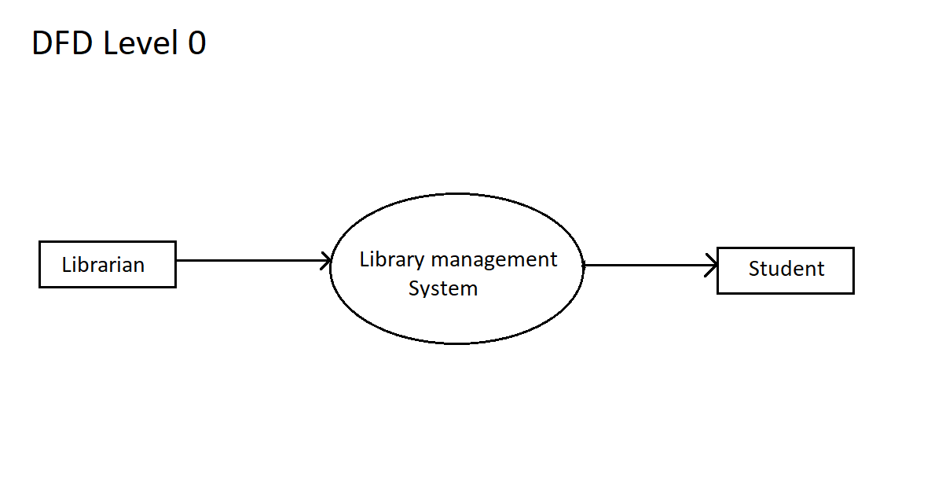
Figure 2
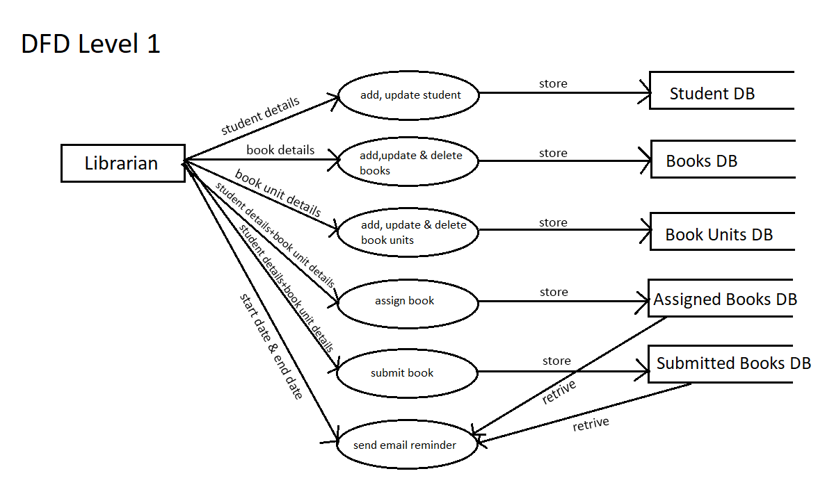
Figure 3
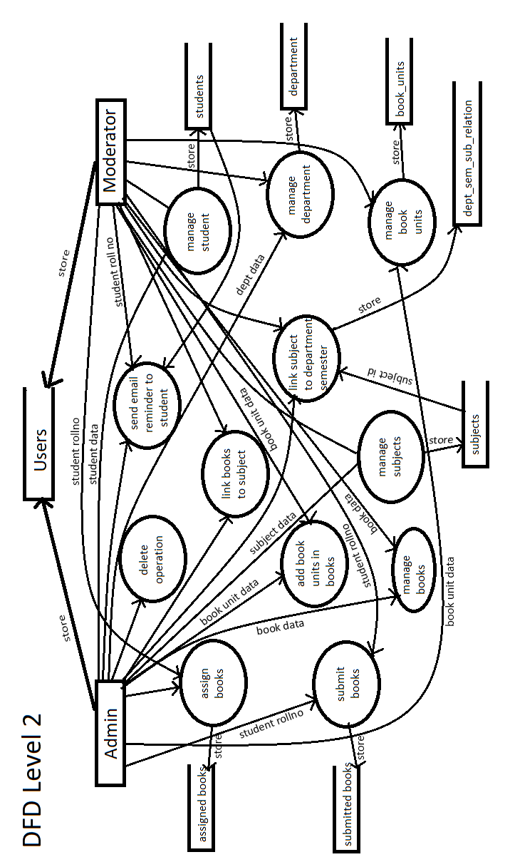
Figure 4
6.3 E-R Diagram
The Entity-Relationship (ER) model was originally proposed by Peter in 1976 as a way to unify the network and relational database views. Simply stated the ER model is a conceptual data model that views the real world as entities and relationships. A basic component of the model is the Entity-Relationship diagram which is used to visually represent data objects. Since Chen wrote his paper the model has been extended and today it is commonly used for database design for the database designer, the utility of the ER model is:
- it maps well to the relational model. The constructs used in the ER model can easily be transformed into relational tables.

- it is simple and easy to understand with a minimum of training. Therefore, the model can be used by the database designer to communicate the design to the end user.

- In addition, the model can be used as a design plan by the database developer to implement a data model in a specific database management software.

6.3.1 ER Diagrams Symbols and Notations
It mainly contains three basic symbols which are rectangle, oval and diamond to represent relationships between elements, entities and attributes. There are some sub-elements which are based on main elements in ER Diagram. ER Diagram is a visual representation of data that describes how data is related to each other using different ER Symbols and Notations.

Entity:
An entity can be a real-world object, either animate or inanimate, that can be easily identifiable. For example, in a school database, students, teachers, classes, and courses offered can be considered as entities. All these entities have some attributes or properties that give them their identity.

Entity
fdfsffdg

Attributes:
Entities are represented by means of their properties, called attributes. All attributes have values. For example, a student entity may have name, class, and age as attributes.

Types of Attributes
- Key attribute − The attribute which uniquely identifies each entity in the entity set is called key attribute. For example, Roll No will be unique for each student. In ER diagram, key attribute is represented by an oval with underlying lines.
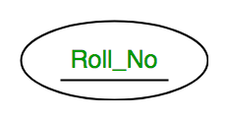

- Composite attribute − Composite attributes are made of more than one simple attribute. For example, a student's address may have street, city, state and country.

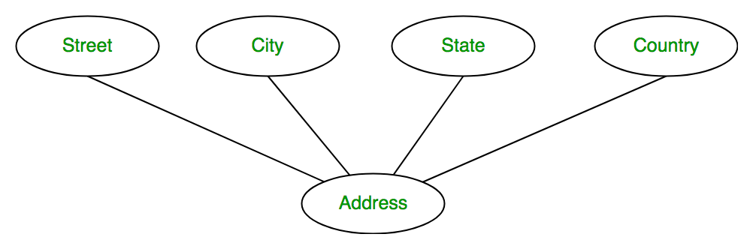
- Derived attribute − Derived attributes are the attributes that do not exist in the physical database, but their values are derived from other attributes present in the database. For example, age can be derived from data_of_birth.

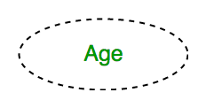

- Multi-value attribute − Multi-value attributes may contain more than one values. For example, a person can have more than one phone number, email_address, etc.

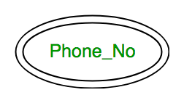

Cardinality:
The number of times an entity of an entity set participates in a relationship set is known as cardinality. Cardinality can be of different types:
- One to one – When each entity in each entity set can take part only once in the relationship, the cardinality is one to one. Let us assume that a male can marry to one female and a female can marry to one male. So the relationship will be one to one.

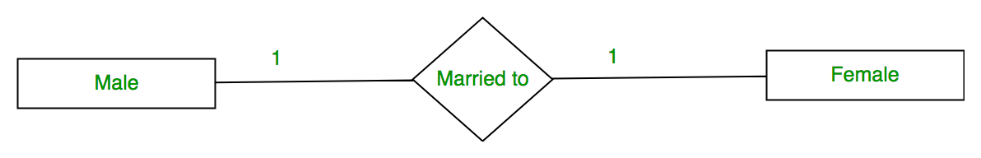
- Many to one – When entities in one entity set can take part only once in the relationship set and entities in other entity set can take part more than once in the relationship set, cardinality is many to one. Let us assume that a student can take only one course but one course can be taken by many students. So the cardinality will be n to 1. It means that for one course there can be n students but for one student, there will be only one course.
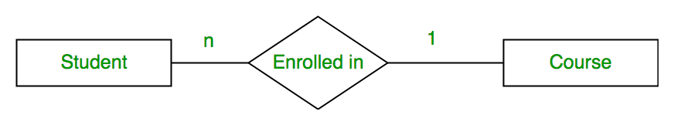
- Many to many – When entities in all entity sets can take part more than once in the relationship cardinality is many to many. Let us assume that a student can take more than one course and one course can be taken by many students. So the relationship will be many to many.
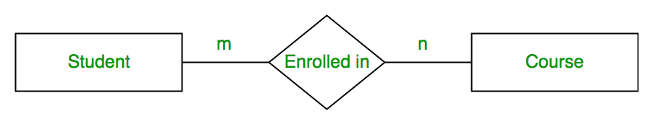

Advantages of ER Model
- Simple: Conceptually ER Model is very easy to build. If we know the relationship between the attributes and the entities, we can easily build the ER Diagram for the model.
- Effective Communication Tool: This model is used widely by the database designers for communicating their ideas.
- Easy Conversion to any Model: This model maps well to the relational model and can be easily converted relational model by converting the ER model to the table.
6.3.2 Library Management Entity-Relation Diagram
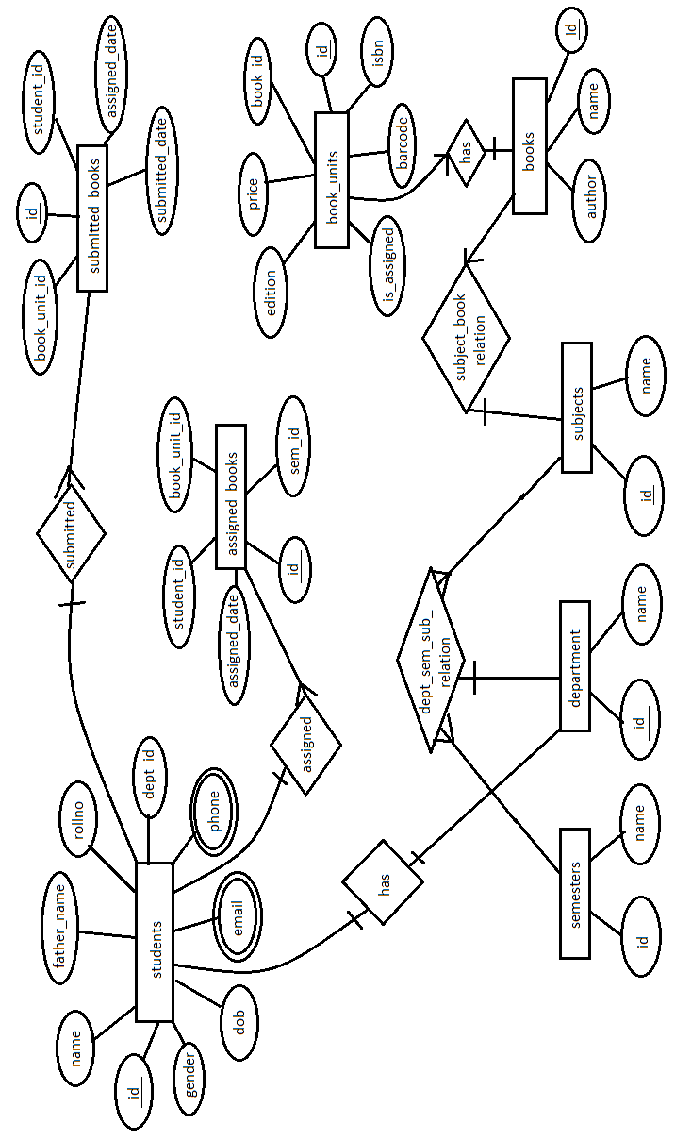
Figure 5
Modules
- Login module: used to login in the system as admin or moderator.
- Student management module: used for registration and search student’s details and update student details.
- Book management module: used for add, delete and edit book and book units. Also search book by name or book unit barcode.
- Book assignment module: used for managing issued or assigned books to students.
- Book submission module: used for managing submit books.
- Send submission reminder module: used for send book reminder to student if student forget to return the books.
- Management Dashboard: used for managing all data at one place easily. There you can see total count of registered students, books, books units and assigned books and pie chart of available books percentage, send email for submission reminder to student, recent assigned and submitted books, double bar chart of weekly assigned and submitted books and many more.
- Send Email Module: used for send email when books assigned, book submitted and send submission reminder to students.
- Extra Modules: There are two extra modules such as department and subject. In department, you can add, delete and edit new department, link semester wise subject to department on the other hand in subject, you can add new add, delete and edit new subject and link books to the subject easily.
Overview of Technologies Used
About Java
Java programming language was originally developed by Sun Microsystems which was initiated by James Gosling and released in 1995 as core component of Sun Microsystems' Java platform (Java 1.0 [J2SE]). The latest release of the Java Standard Edition is Java SE 8. With the advancement of Java and its widespread popularity, multiple configurations were built to suit various types of platforms. For example: J2EE for Enterprise Applications, J2ME for Mobile Applications. The new J2 versions were renamed as Java SE, Java EE, and Java ME respectively. Java is guaranteed to be Write Once, Run Anywhere.
James Gosling initiated Java language project in June 1991 for use in one of his many set-top box projects. The language, initially called ‘Oak’ after an oak tree that stood outside Gosling's office, also went by the name ‘Green’ and ended up later being renamed as Java, from a list of random words.
Sun released the first public implementation as Java 1.0 in 1995. It promised Write Once, Run Anywhere (WORA), providing no-cost run-times on popular platforms. On 13 November, 2006, Sun released much of Java as free and open source software under the terms of the GNU General Public License (GPL). On 8 May, 2007, Sun finished the process, making all of Java's core code free and open-source, aside from a small portion of code to which Sun did not hold the copyright.

Why Java
There are several features that are make your project robust and secure. Some of feature are:
- Object Oriented − In Java, everything is an Object. Java can be easily extended since it is based on the Object model.
- Platform Independent − Unlike many other programming languages including C and C++, when Java is compiled, it is not compiled into platform specific machine, rather into platform independent byte code. This byte code is distributed over the web and interpreted by the Virtual Machine (JVM) on whichever platform it is being run on.
- Simple − Java is designed to be easy to learn. If you understand the basic concept of OOP Java, it would be easy to master.
- Secure − With Java's secure feature it enables to develop virus-free, tamper-free systems. Authentication techniques are based on public-key encryption.
- Architecture-neutral − Java compiler generates an architecture-neutral object file format, which makes the compiled code executable on many processors, with the presence of Java runtime system.
- Portable − Being architecture-neutral and having no implementation dependent aspects of the specification makes Java portable. Compiler in Java is written in ANSI C with a clean portability boundary, which is a POSIX subset.
- Robust − Java makes an effort to eliminate error prone situations by emphasizing mainly on compile time error checking and runtime checking.
- Multithreaded − With Java's multithreaded feature it is possible to write programs that can perform many tasks simultaneously. This design feature allows the developers to construct interactive applications that can run smoothly.
- Interpreted − Java byte code is translated on the fly to native machine instructions and is not stored anywhere. The development process is more rapid and analytical since the linking is an incremental and light-weight process.
- High Performance − With the use of Just-In-Time compilers, Java enables high performance.
- Distributed − Java is designed for the distributed environment of the internet.
- Dynamic − Java is considered to be more dynamic than C or C++ since it is designed to adapt to an evolving environment. Java programs can carry extensive amount of run-time information that can be used to verify and resolve accesses to objects on run-time.
About JSP
Java Server Pages (JSP) is a technology for developing Webpages that supports dynamic content. This helps developers insert java code in HTML pages by making use of special JSP tags, most of which start with <% and end with %>.
A Java Server Pages component is a type of Java servlet that is designed to fulfil the role of a user interface for a Java web application. Web developers write JSPs as text files that combine HTML or XHTML code, XML elements, and embedded JSP actions and commands.
Using JSP, you can collect input from users through Webpage forms, present records from a database or another source, and create Webpages dynamically. JSP tags can be used for a variety of purposes, such as retrieving information from a database or registering user preferences, accessing JavaBeans components, passing control between pages, and sharing information between requests, pages etc.
While JSP may not be your first choice for building dynamic web pages, it is a core Java web technology. JSP pages are relatively quick and easy to build, and they interact seamlessly with Java servlets in a servlet container like Tomcat.
Why JSP
Java Server Pages often serve the same purpose as programs implemented using the Common Gateway Interface (CGI). But JSP offers several advantages in comparison with the CGI.
- Performance is significantly better because JSP allows embedding Dynamic Elements in HTML Pages itself instead of having separate CGI files.
- JSP are always compiled before they are processed by the server unlike CGI/Perl which requires the server to load an interpreter and the target script each time the page is requested.
- Java Server Pages are built on top of the Java Servlets API, so like Servlets, JSP also has access to all the powerful Enterprise Java APIs, including JDBC, JNDI, EJB, JAXP, etc.
- JSP pages can be used in combination with servlets that handle the business logic, the model supported by Java servlet template engines.
Finally, JSP is an integral part of Java EE, a complete platform for enterprise class applications. This means that JSP can play a part in the simplest applications to the most complex and demanding.
About HTML
HTML, which stands for Hyper Text Markup Language, is the predominant markup language for web pages. It provides a means to create structured documents by denoting structural semantics for text such as headings, paragraphs, lists etc. as well as for links, quotes, and other items. It allows images and objects to be embedded and can be used to create interactive forms. It is written in the form of HTML elements consisting of "tags" surrounded by angle brackets within the web page content. It can include or can load scripts in languages such as JavaScript which affect the behavior of HTML processors like Web browsers; and Cascading Style Sheets (CSS) to define the appearance and layout of text and other material. The W3C, maintainer of both HTML and CSS standards, encourages the use of CSS over explicit presentational markup.
Hyper Text Markup Language (HTML) is the encoding scheme used to create and format a web document. A user need not be an expert programmer to make use of HTML for creating hypertext documents that can be put on the internet. Most graphical e-mail clients allow the use of a subset of HTML (often ill-defined) to provide formatting and semantic markup not available with plain text. This may include typographic information like colored headings, emphasized and quoted text, inline images and diagrams. Many such clients include both a GUI editor for composing HTML e-mail messages and a rendering engine for displaying them. Use of HTML in e-mail is controversial because of compatibility issues, because it can help disguise phishing attacks, because it can confuse spam filters and because the message size is larger than plain text.
Naming Conventions
The most common filename extension for files containing HTML is .html. A common abbreviation of this is .htm, which originated because some early operating systems and file systems, such as DOS and FAT, limited file extensions to three letters.
HTML Application
An HTML Application is a Microsoft Windows application that uses HTML and Dynamic HTML in a browser to provide the application's graphical interface. A regular HTML file is confined to the security model of the web browser, communicating only to web servers and manipulating only webpage objects and site cookies. An HTA runs as a fully trusted application and therefore has more privileges, like creation/editing/removal of files and Windows Registry entries. Because they operate outside the browser's security model, HTAs cannot be executed via HTTP, but must be downloaded (just like an EXE file) and executed from local file system.
About JavaScript
JavaScript is an object-oriented scripting language used to enable programmatic access to objects within both the client application and other applications. It is primarily used in the form of client-side JavaScript, implemented as an integrated component of the web browser, allowing the development of enhanced user interfaces and dynamic websites. JavaScript is a dialect of the ECMAScript standard and is characterized as a dynamic, weakly typed, prototype-based language with first-class functions. JavaScript was influenced by many languages and was designed to look like Java, but to be easier for non-programmers to work with.
JavaScript Usage
The primary use of JavaScript is to write functions that are embedded in or included from HTML pages and interact with the Document Object Model (DOM) of the page.
Because JavaScript code can run locally in a user's browser (rather than on a remote server) it can respond to user actions quickly, making an application feel more responsive. Furthermore, JavaScript code can detect user actions which HTML alone cannot, such as individual keystrokes. Applications such as Gmail take advantage of this: much of the user-interface logic is written in JavaScript, and JavaScript dispatches requests for information (such as the content of an e-mail message) to the server. The wider trend of Ajax programming similarly exploits this strength.
A JavaScript engine (also known as JavaScript interpreter or JavaScript implementation) is an interpreter that interprets JavaScript source code and executes the script accordingly. The first JavaScript engine was created by Brendan Eich at Netscape Communications Corporation, for the Netscape Navigator web browser. A web browser is by far the most common host environment for JavaScript. Web browsers typically use the public API to create "host objects" responsible for reflecting the DOM into JavaScript.
About JQuery
jQuery is a small, light-weight and fast JavaScript library. It is cross-platform and supports different types of browsers. It is also referred as? write less do more? because it takes a lot of common tasks that requires many lines of JavaScript code to accomplish, and binds them into methods that can be called with a single line of code whenever needed. It is also very useful to simplify a lot of the complicated things from JavaScript, like AJAX calls and DOM manipulation.
- jQuery is a small, fast and lightweight JavaScript library.
- jQuery is platform-independent.
- jQuery means "write less do more".
- jQuery simplifies AJAX call and DOM manipulation.

About Ajax
AJAX stands for Asynchronous JavaScript and XML. AJAX is a new technique for creating better, faster, and more interactive web applications with the help of XML, HTML, CSS, and Java Script.
- Ajax uses XHTML for content, CSS for presentation, along with Document Object Model and JavaScript for dynamic content display.
- Conventional web applications transmit information to and from the sever using synchronous requests. It means you fill out a form, hit submit, and get directed to a new page with new information from the server.
- With AJAX, when you hit submit, JavaScript will make a request to the server, interpret the results, and update the current screen. In the purest sense, the user would never know that anything was even transmitted to the server.
- XML is commonly used as the format for receiving server data, although any format, including plain text, can be used.
- AJAX is a web browser technology independent of web server software.
- A user can continue to use the application while the client program requests information from the server in the background.
- Intuitive and natural user interaction. Clicking is not required, mouse movement is a sufficient event trigger.
- Data-driven as opposed to page-driven.
About ChartJS
Chart.js is a free open-source JavaScript library for data visualization, which supports 8 chart types: bar, line, area, pie (doughnut), bubble, radar, polar, and scatter. Created by London-based web developer Nick Downie in 2013, now it is maintained by the community and is the second most popular JS charting library on GitHub by the number of stars after D3.js, considered significantly easier to use though less customizable than the latter. Chart.js renders in HTML5 canvas and is widely covered as one of the best data visualization libraries. It is available under the MIT license.
About SweetAlert 2
SweetAlert is a method to customize alerts in your applications, websites and games. It allows the user to change it with a standard JavaScript button. You can add a new button to it, change the background colour of the button, change the button's text, and add additional alerts that depend on the user's click. You can also put the icons with your alerts message in it.
SweetAlert is a replacement for the "window.alert()" function of JavaScript that shows wonderful modal popup windows. It is a standalone library with no dependencies and is composed of a JavaScript file plus a CSS file.
About Oracle
Larry Ellison and his two friends and former co-workers, Bob Miner and Ed Oates, started a consultancy called Software Development Laboratories (SDL) in 1977. SDL developed the original version of the Oracle software. The name Oracle comes from the code-name of a CIA-funded project Ellison had worked on while formerly employed by Ampex.
An Oracle database is a collection of data treated as a unit. The purpose of a database is to store and retrieve related information. A database server is the key to solving the problems of information management. In general, a server reliably manages a large amount of data in a multiuser environment so that many users can concurrently access the same data. All this is accomplished while delivering high performance. A database server also prevents unauthorized access and provides efficient solutions for failure recovery.
Oracle Database is the first database designed for enterprise grid computing, the most flexible and cost effective way to manage information and applications. Enterprise grid computing creates large pools of industry-standard, modular storage and servers. With this architecture, each new system can be rapidly provisioned from the pool of components. There is no need for peak workloads, because capacity can be easily added or reallocated from the resource pools as needed.
The database has logical structures and physical structures. Because the physical and logical structures are separate, the physical storage of data can be managed without affecting the access to logical storage structures.

Database Tables
Assigned Books Table
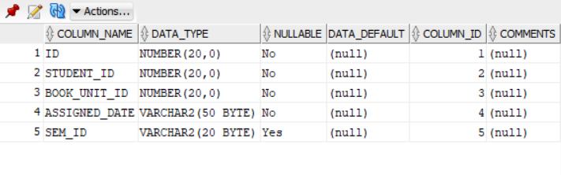
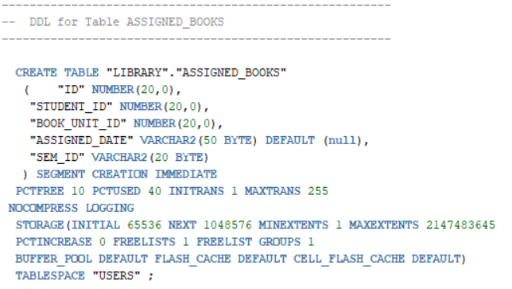
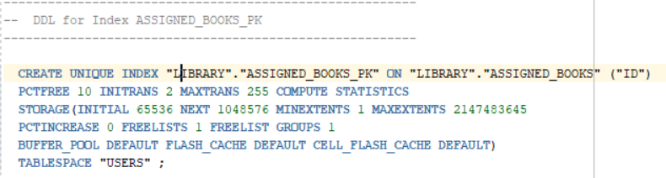
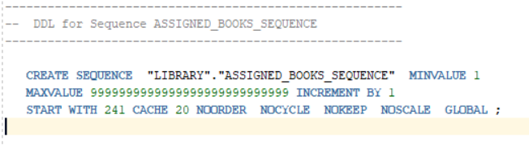
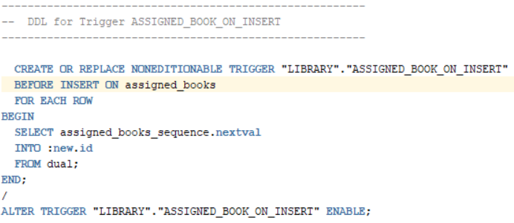
Book Units Table
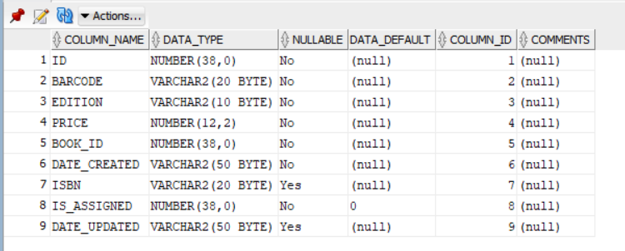
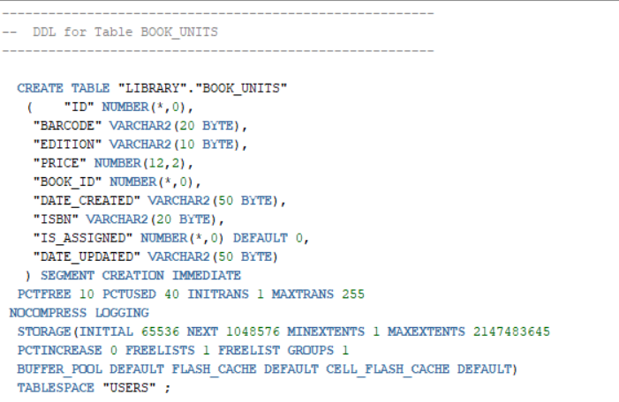
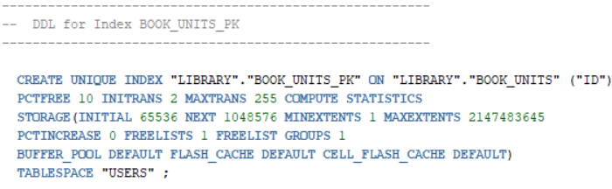
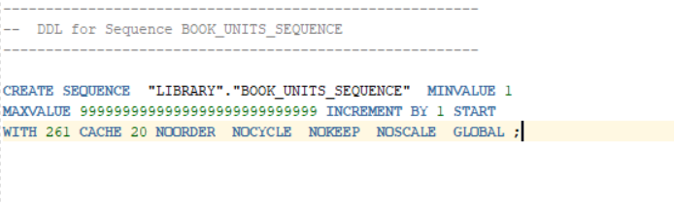
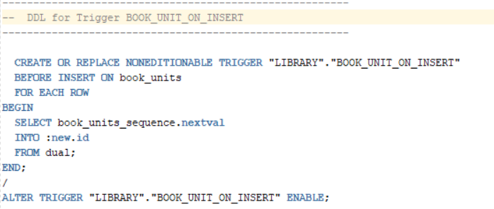
Books Table
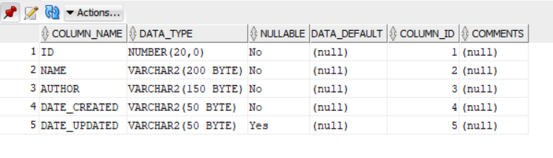
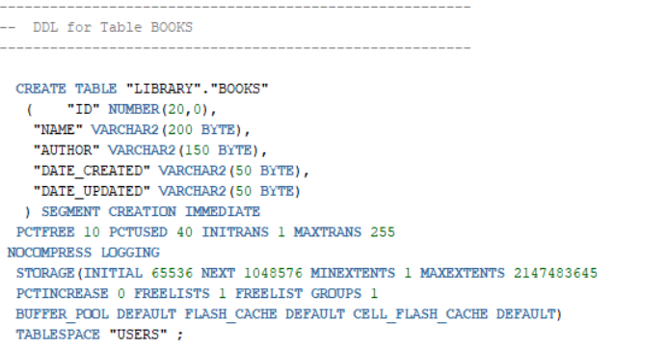
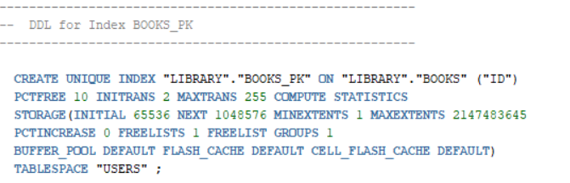
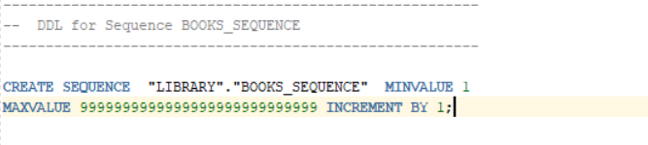
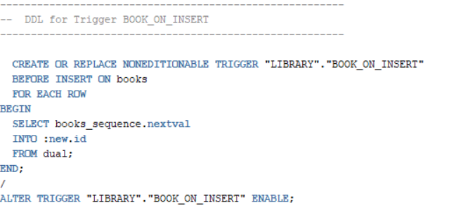
Departments Table
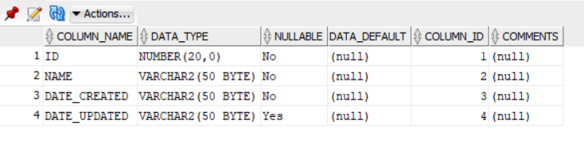
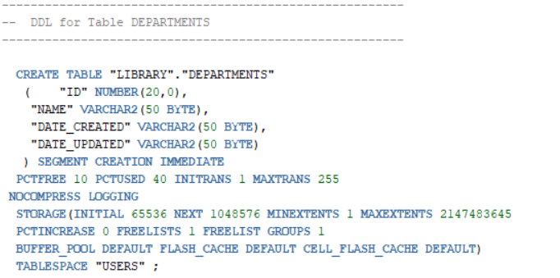
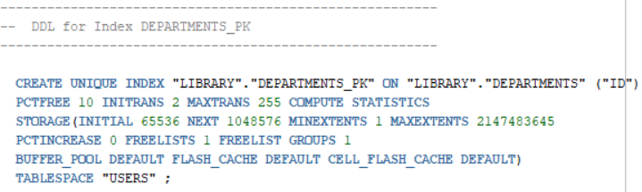
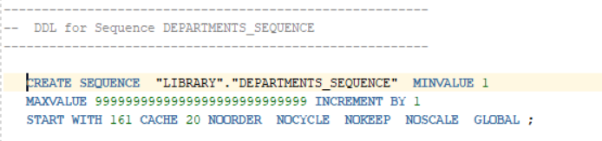
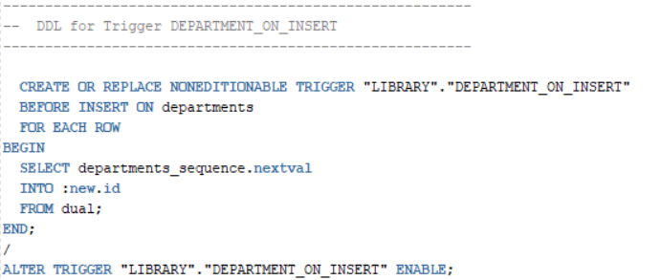
Semester Table
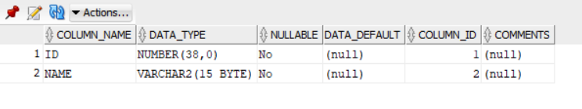
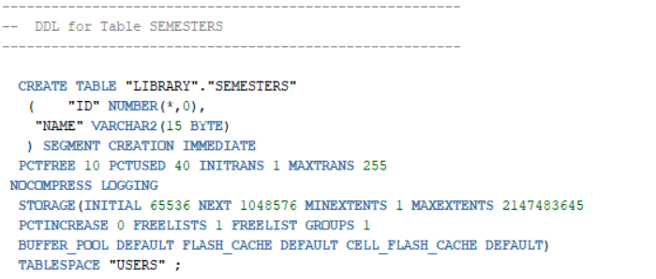

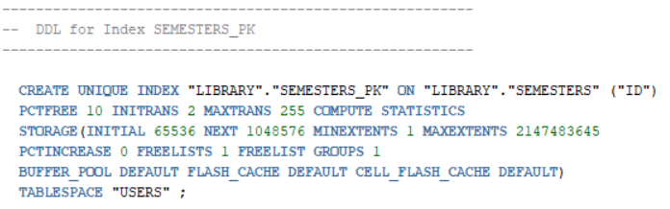
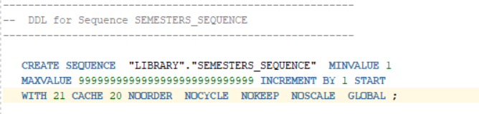
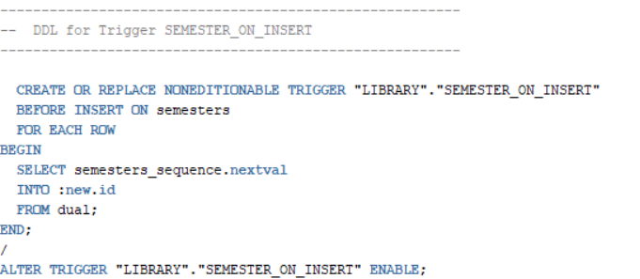

Students Tables
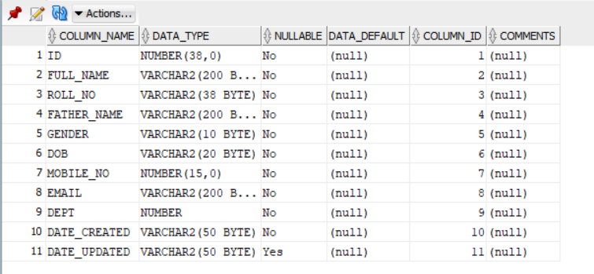
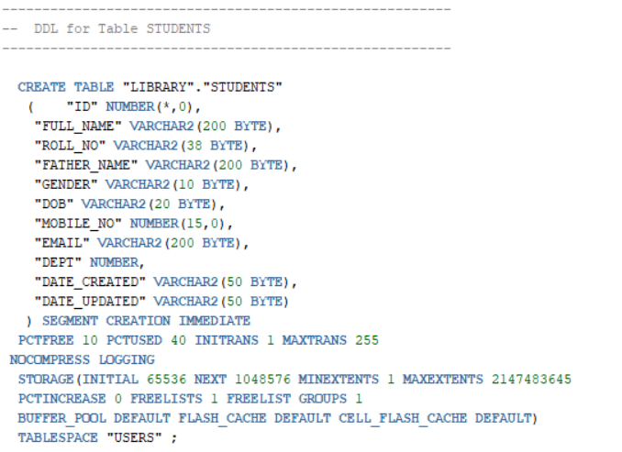

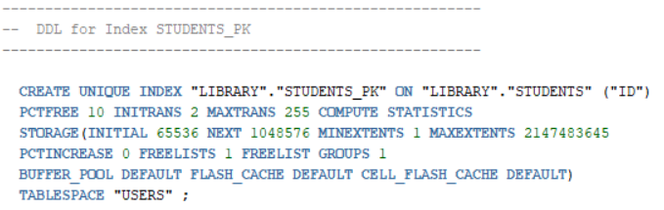
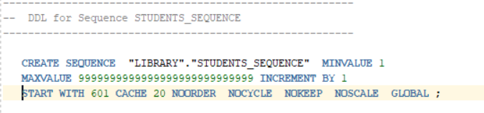
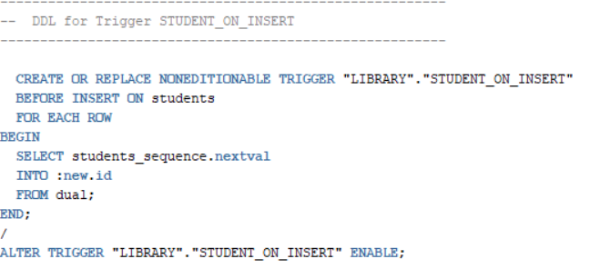
Subjects Table
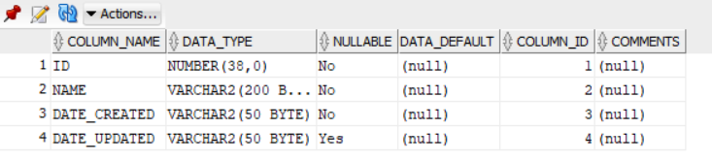
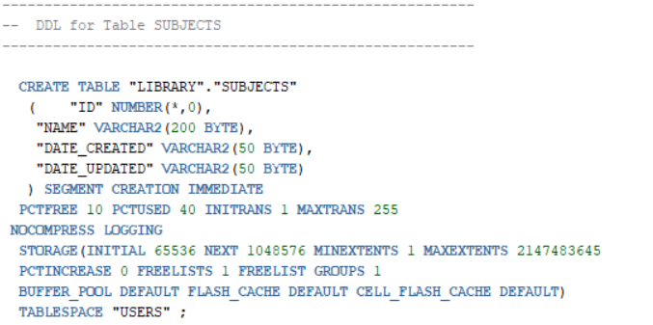
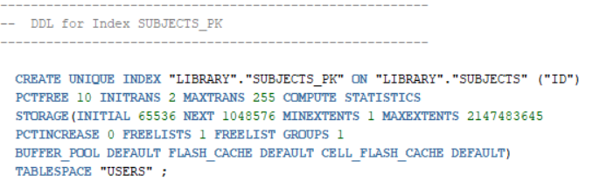
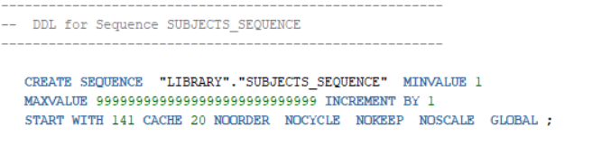
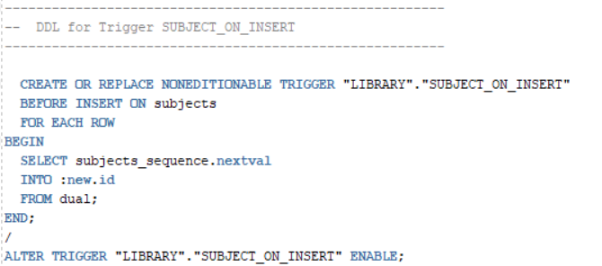
Submitted Books Table
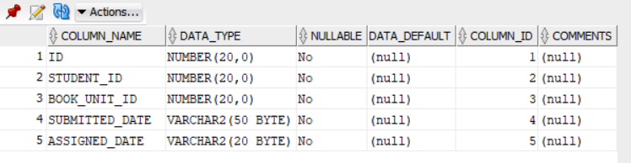
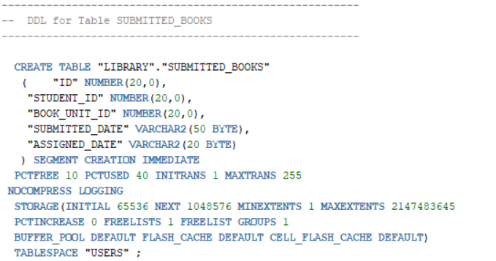
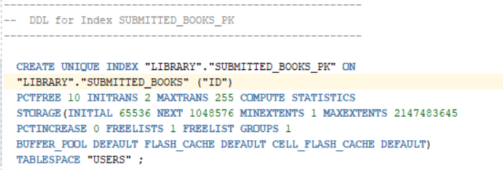

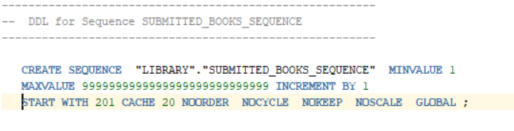
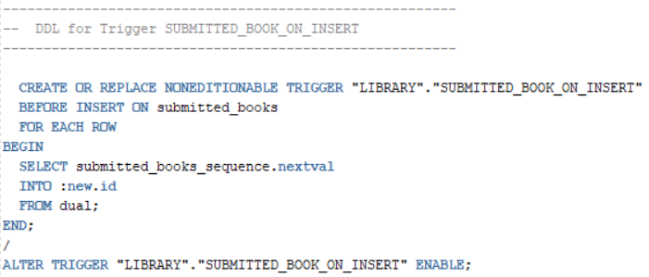
Depts Sem Subject Relation Table
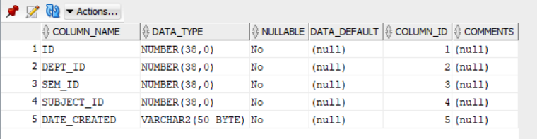
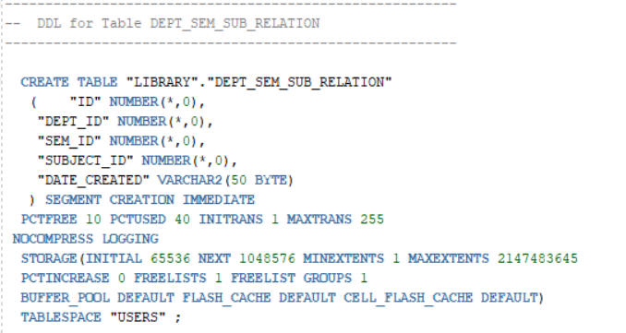
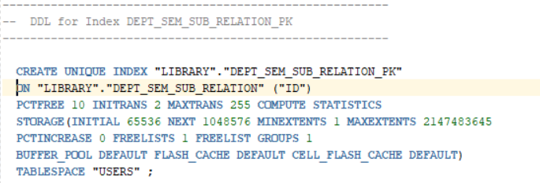
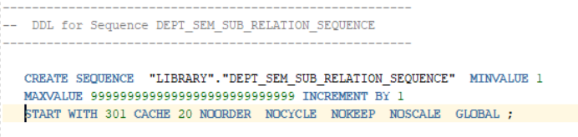

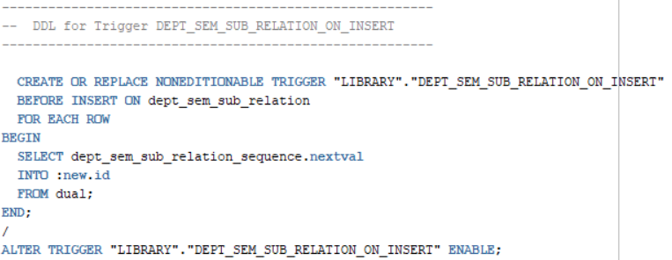
Subject Book Relation Table
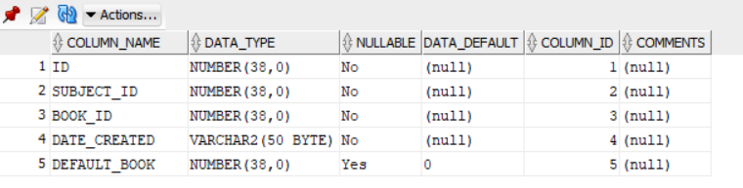
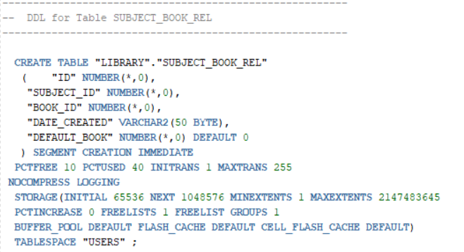
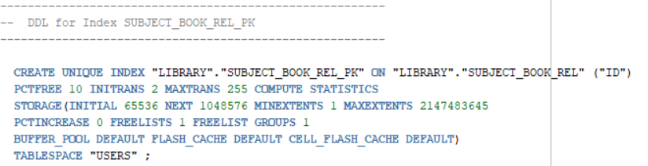

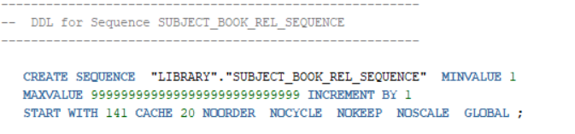

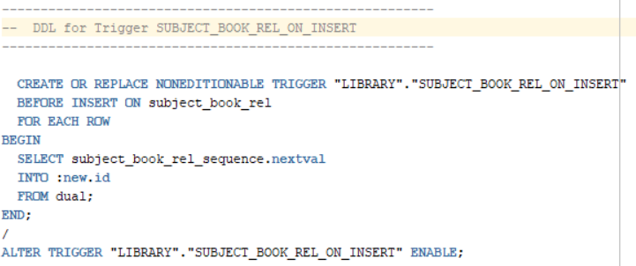

Mail Send Table
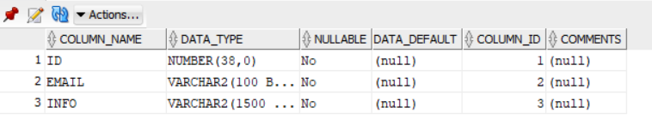
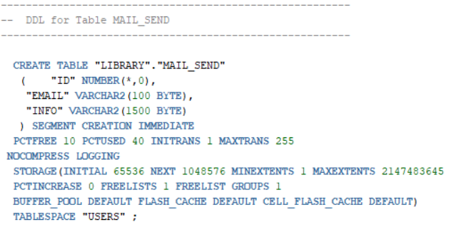
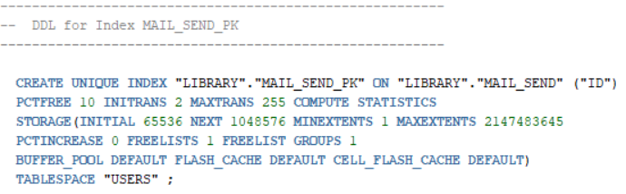
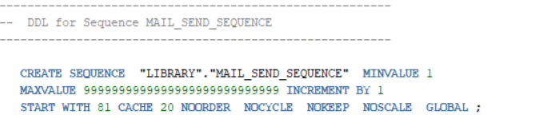
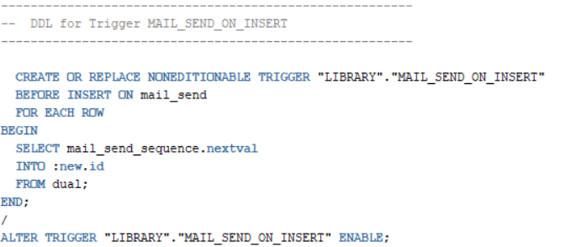
Users Tables
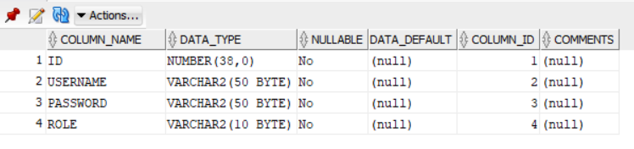
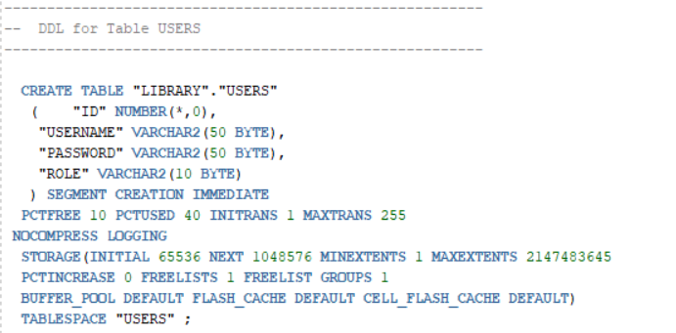

Dept Sem Subject View
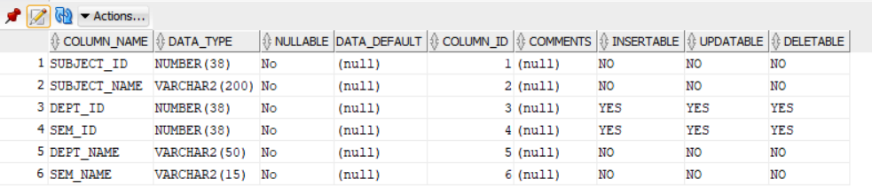
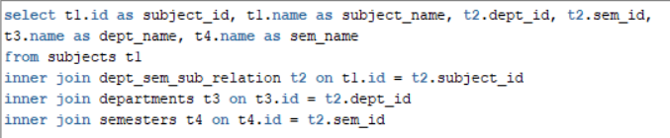
Subject Book View
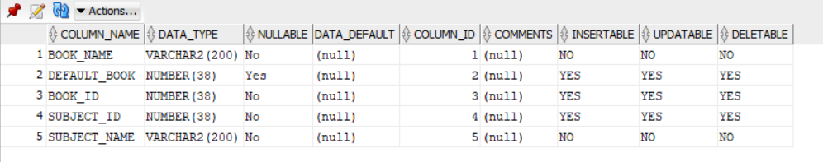
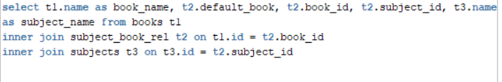

Implementation
Implementation is the stage where the theoretical design is turned into a working system. The most crucial stage in achieving a new successful system and in giving confidence on the new system for the users that it will work efficiently and effectively.
The system can be implemented only after thorough testing is done and if it is found to work according to the specification.
It involves careful planning, investigation of the current system and its constraints on implementation, design of methods to achieve the changeover and an evaluation of change over methods a part from planning. Two major tasks of preparing the implementation are education and training of the users and testing of the system.
The more complex the system being implemented, the more involved will be the systems analysis and design effort required just for implementation.
The implementation phase comprises of several activities. The required hardware and software acquisition is carried out. The system may require some software to be developed. For this, programs are written and tested. The user then changes over to his new fully tested system and the old system is discontinued.
Maintenance and Environment
As the number of computer based systems, grieve libraries of computer software began to expand. In house developed projects produced tones of thousand soft program source statements. Software products purchased from the outside added hundreds of thousands of new statements. A dark cloud appeared on the horizon. All of these programs, all of those source statements-had to be corrected when false were detected, modified as user requirements changed, or adapted to new hardware that was purchased. These activities were collectively called software Maintenance.
The maintenance phase focuses on change that is associated with error correction, adaptations required as the software's environment evolves, and changes due to enhancements brought about by changing customer requirements. Four types of changes are encountered during the maintenance phase.
  - Correction
Even with the best quality assurance activities is lightly that the customer will uncover defects in the software. Corrective maintenance changes the software to correct defects.
Maintenance is a set of software Engineering activities that occur after software has been delivered to the customer and put into operation. Software configuration management is a set of tracking and control activities that began when a software project begins and terminates only when the software is taken out of the operation.
We may define maintenance by describing four activities that are undertaken after a program is released for use:
- Corrective Maintenance
- Adaptive Maintenance
- Perfective Maintenance or Enhancement
- Preventive Maintenance or reengineering
Only about 20 percent of all maintenance work are spent "fixing mistakes". The remaining 80 percent are spent adapting existing systems to changes in their external environment, making enhancements requested by users, and reengineering an application for use.
  - Adaptation
Over time, the original environment (E>G., CPU, operating system, business rules, external product characteristics) for which the software was developed is likely to change. Adaptive maintenance results in modification to the software to accommodate change to its external environment.
  - Enhancement
As software is used, the customer/user will recognize additional functions that will provide benefit. Perceptive maintenance extends the software beyond its original function requirements.
  - prevention
Computer software deteriorates due to change, and because of this, preventive maintenance, often called software re-engineering, and must be conducted to enable the software to serve the needs of its end users. In essence, preventive maintenance makes changes to computer programs so that they can be more easily corrected, adapted, and enhanced. Software configuration management (SCM) is an umbrella activity that is applied throughout the software process.
Software Methodology
The software methodology followed in this project includes the object - oriented methodology and the application system development methodologies. The description of these methodologies is given below.
Application System Development – A Life Cycle Approach
Although there are a growing number of applications (such as decision support systems) that should be developed using an experimental process strategy such as prototyping, a significant amount of new development work continues to involve major operational applications of broad scope. The application systems are large highly structured. User task comprehension and developer task proficiency is usually high. These factors suggest a linear or iterative assurance strategy. The most common method for this stage class of problems is a system development life cycle modal in which each stage of development is well defined and has straightforward requirements for deliverables, feedback and sign off. The system development life cycle is described in detail since it continues to be an appropriate methodology for a significant part of new development work.
The basic idea of the system development life cycle is that there is a well-defined process by which an application is conceived and developed and implemented. The life cycle gives structure to a creative process. In order to manage and control the development effort, it is necessary to know what should have been done, what has been done, and what has yet to be accomplished. The phrases in the system development life cycle provide a basis for management and control because they define segments of the flow of work, which can be identified for managerial purposes and specifies the documents or other deliverables to be produced in each phase.
The phases in the life cycle for information system development are described differently by different writers, but the differences are primarily in the amount of necessity and manner of categorization. There is a general agreement on the flow of development steps and the necessity for control procedures at each stage.
The information system development cycle for an application consists of three major stages.
- Definition
- Design
- Development
- Installation and operation
The first stage of the process, which defines the information requirements for a feasible cost effective system. The requirements are then translated into a physical system of forms, procedures, programs etc., by the system design, computer programming and procedure development. The resulting system is test and put into operation. No system is perfect so there is always a need for maintenance changes. To complete the cycle, there should be a post audit of the system to evaluate how well it performs and how well it meets the cost and performance specifications. The stages of definition, development and installation and operation can therefore be divided into smaller steps or phrases as follows.
- Definition
Proposed definition: Preparation of request for proposed applications.
Feasibility assessment: Evaluation of feasibility and cost benefit of
proposed system.
Information requirement analysis: determination of information
needed.
- Design
Conceptual design: User-oriented design of application development.
Physical system design: Detailed design of flows and processes in applications processing system and preparation of program specification.
- Development
Program development: coding and testing of computer programs.
Procedure development: design of procedures and preparation of user
instructions.
- Installation and operation
Conversion: final system test and conversion.
Operation and maintenance: Month to month operation and maintenance
Post audit: Evaluation of development process, application system and results of use at the completion of each phase, formal approval sign-off is required from the users as well as from the manager of the project development.

Testing
Testing is a process of executing a program with the intent of finding an error. Testing is a crucial element of software quality assurance and presents ultimate review of specification, design and coding.
System Testing is an important phase. Testing represents an interesting anomaly for the software. Thus a series of testing are performed for the proposed system before the system is ready for user acceptance testing. A good test case is one that has a high probability of finding an as undiscovered error. A successful test is one that uncovers an as undiscovered error.
Testing Objectives:
- Testing is a process of executing a program with the intent of finding an error.
- A good test case is one that has a probability of finding an as yet undiscovered error.
- A successful test is one that uncovers an undiscovered error.
Testing Principles:
- All tests should be traceable to end user requirements.
- Tests should be planned long before testing begins.
- Testing should begin on a small scale and progress towards testing in large.
- Exhaustive testing is not possible.
- To be most effective testing should be conducted by an independent third party.
The primary objective for test case design is to derive a set of tests that has the highest livelihood for uncovering defects in software. To accomplish this objective two different categories of test case design techniques are used. They are
- White box testing.

- Black box testing.

White-box testing:
White box testing focus on the program control structure. Test cases are derived to ensure that all statements in the program have been executed at least once during testing and that all logical conditions have been executed.
Block-box testing:
Black box testing is designed to validate functional requirements without regard to the internal workings of a program. Black box testing mainly focuses on the information domain of the software, deriving test cases by partitioning input and output in a manner that provides through test coverage. Incorrect and missing functions, interface errors, errors in data structures, error in functional logic are the errors falling in this category.
Testing strategies:
A strategy for software testing must accommodate low-level tests that are necessary to verify that all small source code segment has been correctly implemented as well as high-level tests that validate major system functions against customer requirements.
Testing fundamentals:
Testing is a process of executing program with the intent of finding error. A good test case is one that has high probability of finding an undiscovered error. If testing is conducted successfully it uncovers the errors in the software. Testing cannot show the absence of defects, it can only show that software defects present.
Testing Information flow:
Information flow for testing flows the pattern. Two class of input provided to test the process. The software configuration includes a software requirements specification, a design specification and source code. Test configuration includes test plan and test cases and test tools. Tests are conducted and all the results are evaluated. That is test results are compared with expected results. When erroneous data are uncovered, an error is implied and debugging commences.
Unit testing:
Unit testing is essential for the verification of the code produced during the coding phase and hence the goal is to test the internal logic of the modules. Using the detailed design description as a guide, important paths are tested to uncover errors with in the boundary of the modules. These tests were carried out during the programming stage itself. All units of ViennaSQL were successfully tested.
Integration testing:
Integration testing focuses on unit tested modules and build the program structure that is dictated by the design phase.
System testing:
System testing tests the integration of each module in the system. It also tests to find discrepancies between the system and its original objective, current specification and system documentation. The primary concern is the compatibility of individual modules. Entire system is working properly or not will be tested here, and specified path ODBC connection will correct or not, and giving output or not are tested here these verifications and validations are done by giving input values to the system and by comparing with expected output. Top-down testing implementing here.
Acceptance Testing:
This testing is done to verify the readiness of the system for the implementation. Acceptance testing begins when the system is complete. Its purpose is to provide the end user with the confidence that the system is ready for use. It involves planning and execution of functional tests, performance tests and stress tests in order to demonstrate that the implemented system satisfies its requirements.
Tools to special importance during acceptance testing include:
Test coverage Analyzer – records the control paths followed for each test case.
Timing Analyzer – also called a profiler, reports the time spent in various regions of the code are areas to concentrate on to improve system performance.
Coding standards – static analyzers and standard checkers are used to inspect code for deviations from standards and guidelines.
Test Cases:
Test cases are derived to ensure that all statements in the program have been executed at least once during testing and that all logical conditions have been executed. Using White-Box testing methods, the software engineer can drive test cases that
- Guarantee that logical decisions on their true and false sides.

- Exercise all logical decisions on their true and false sides.

- Execute all loops at their boundaries and within their operational bounds.

- Exercise internal data structure to assure their validity.

Output Screens
Login Screen
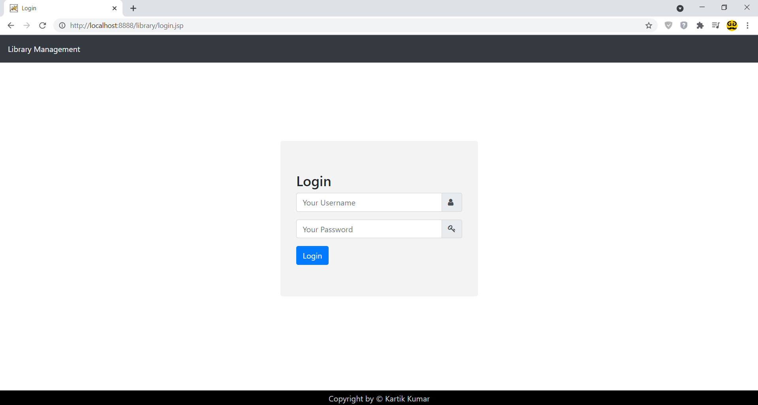
Dashboard Screen
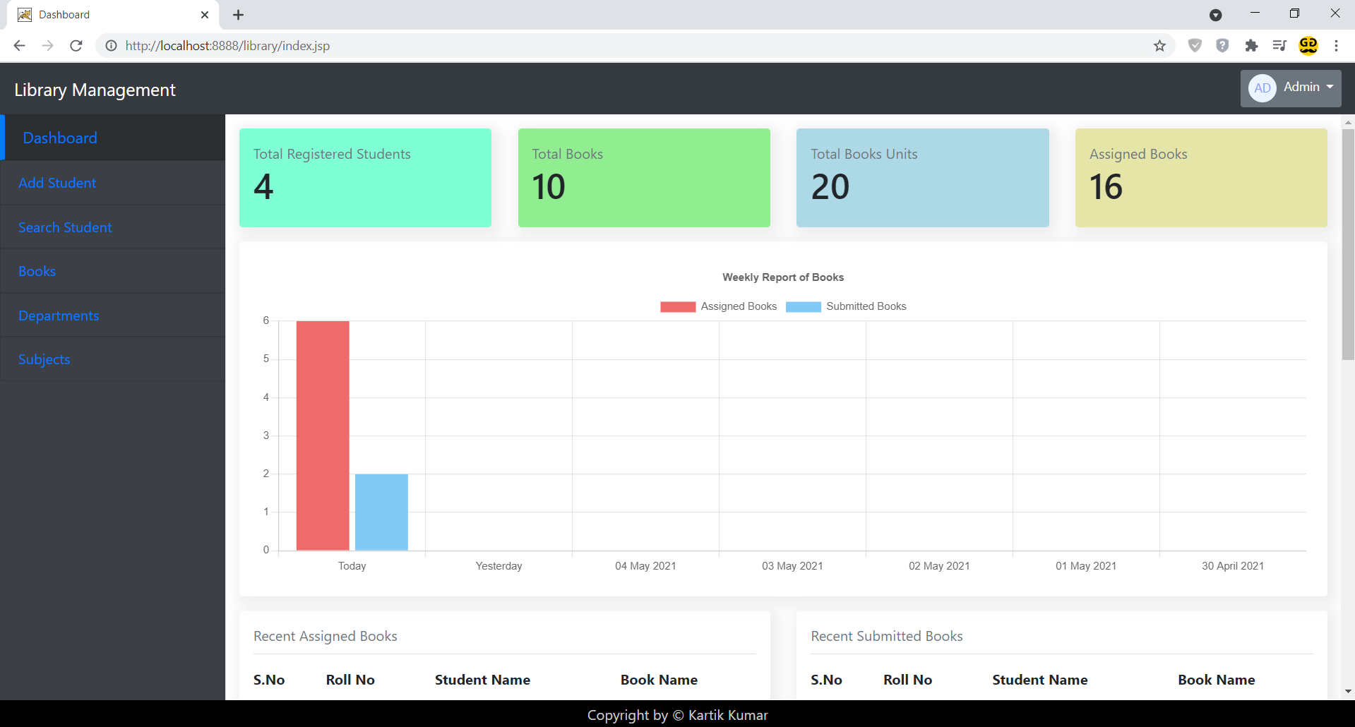
Add Student Screen
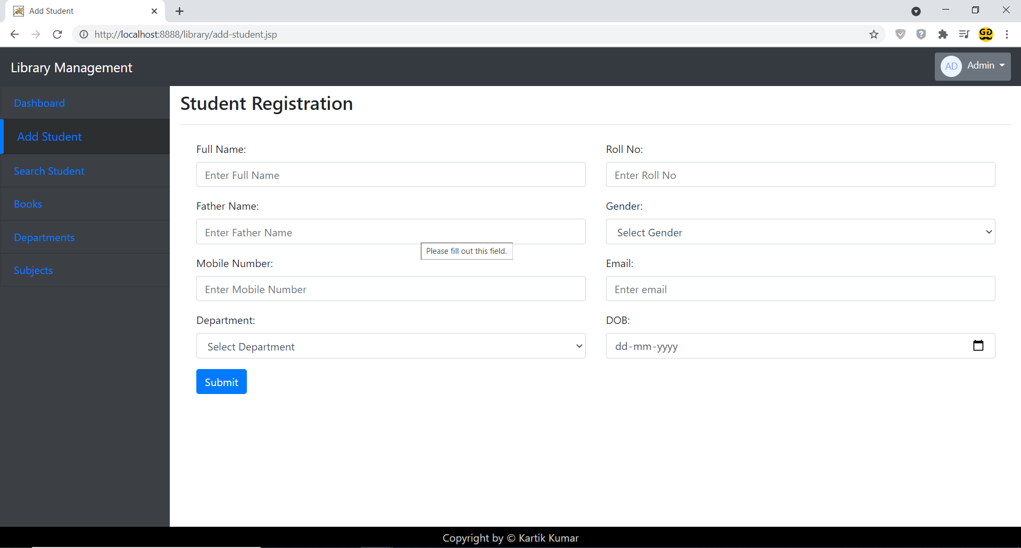
Search Student Screen
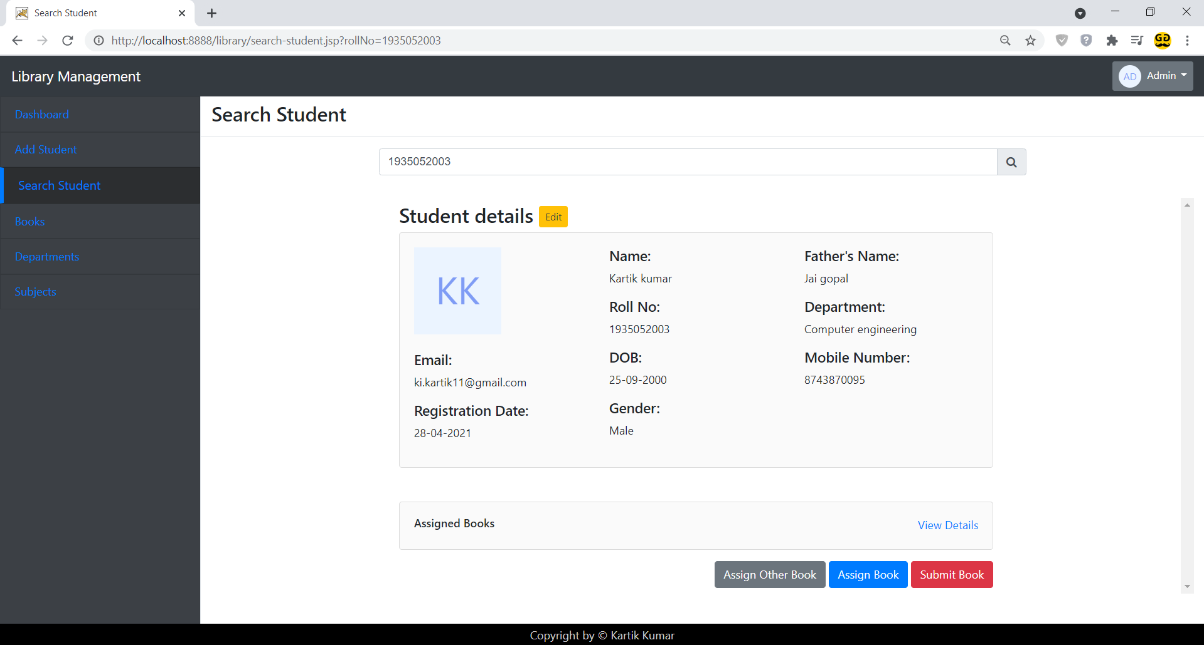
Assigned Books to Student Modal
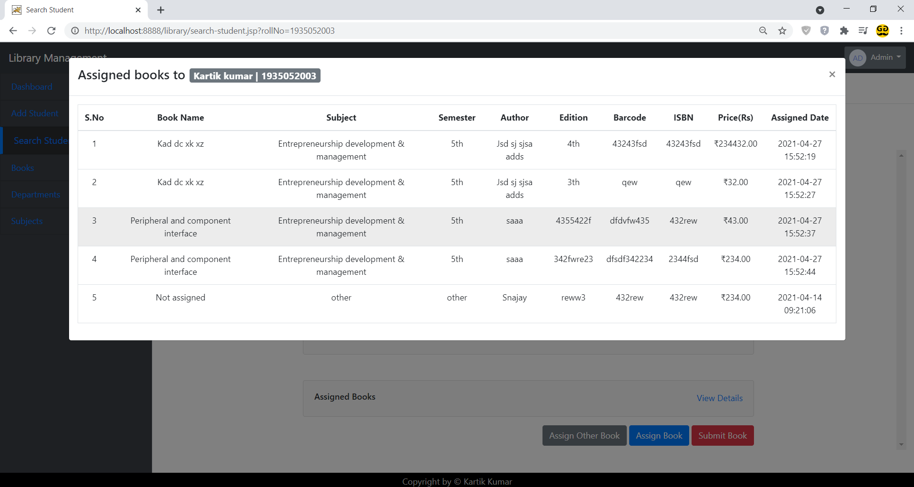
Assign Book to Student Screen
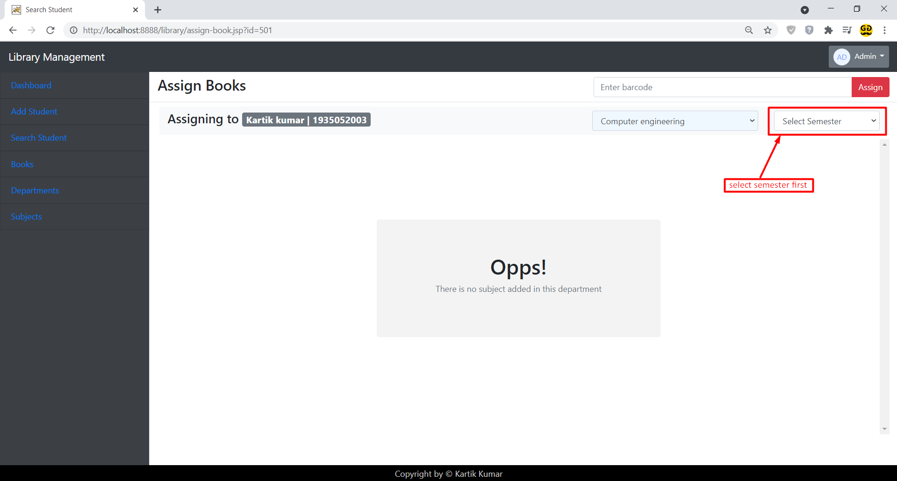
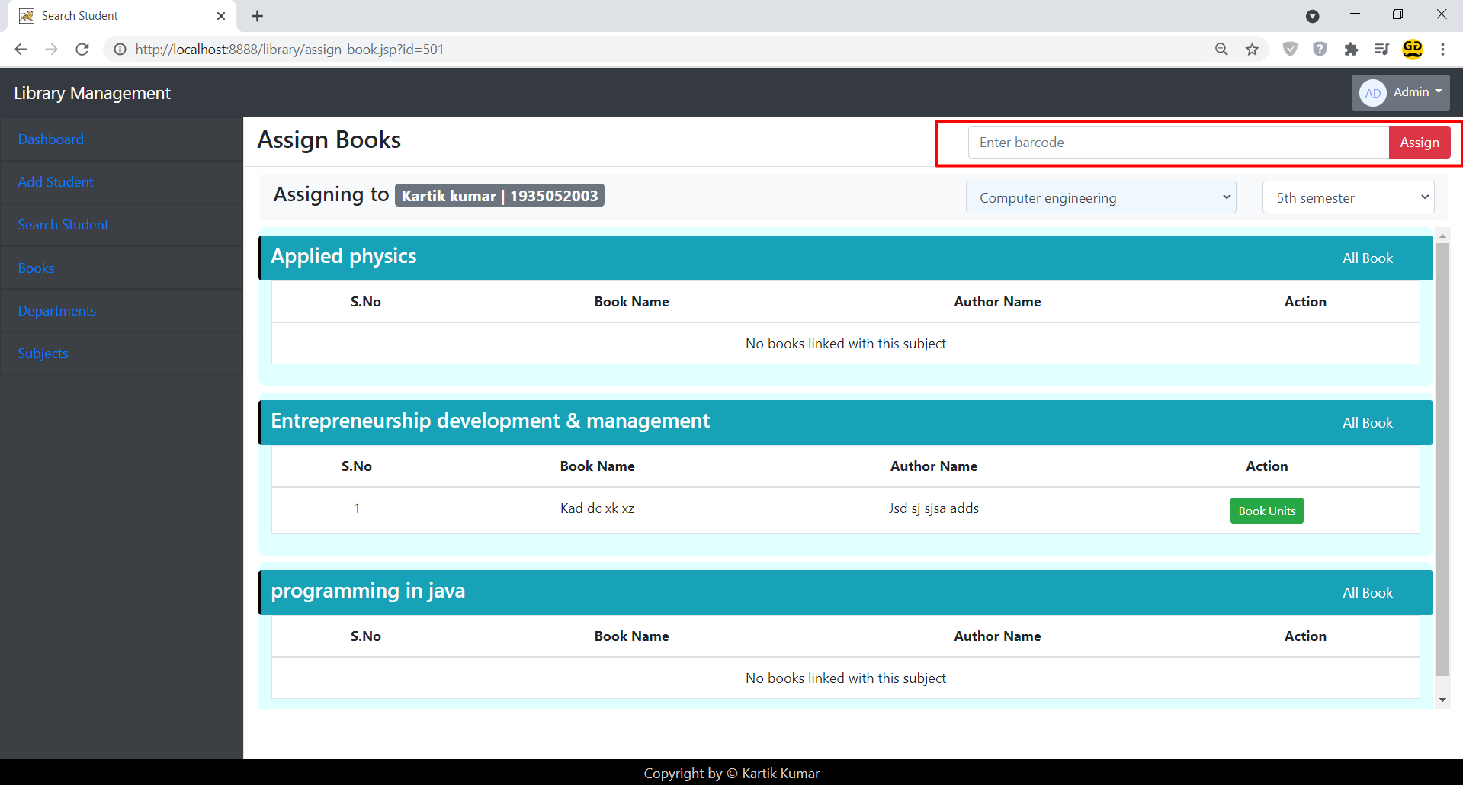
Assign Other Books to Student Modal
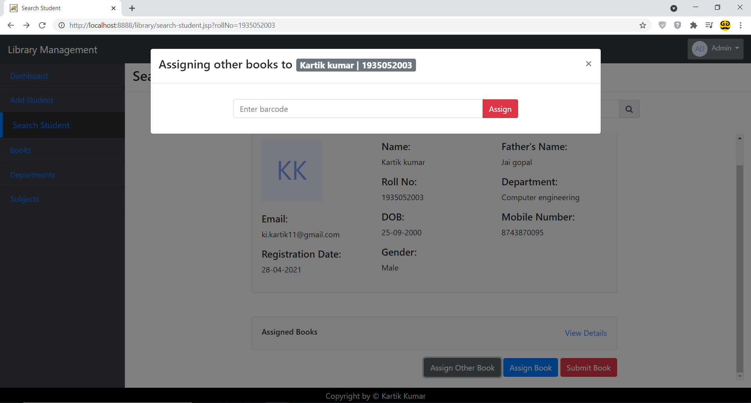

Submit Book from Student
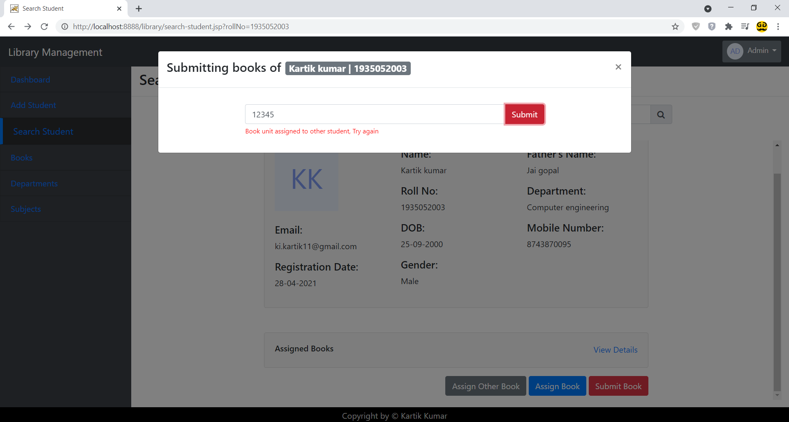
Books Screen
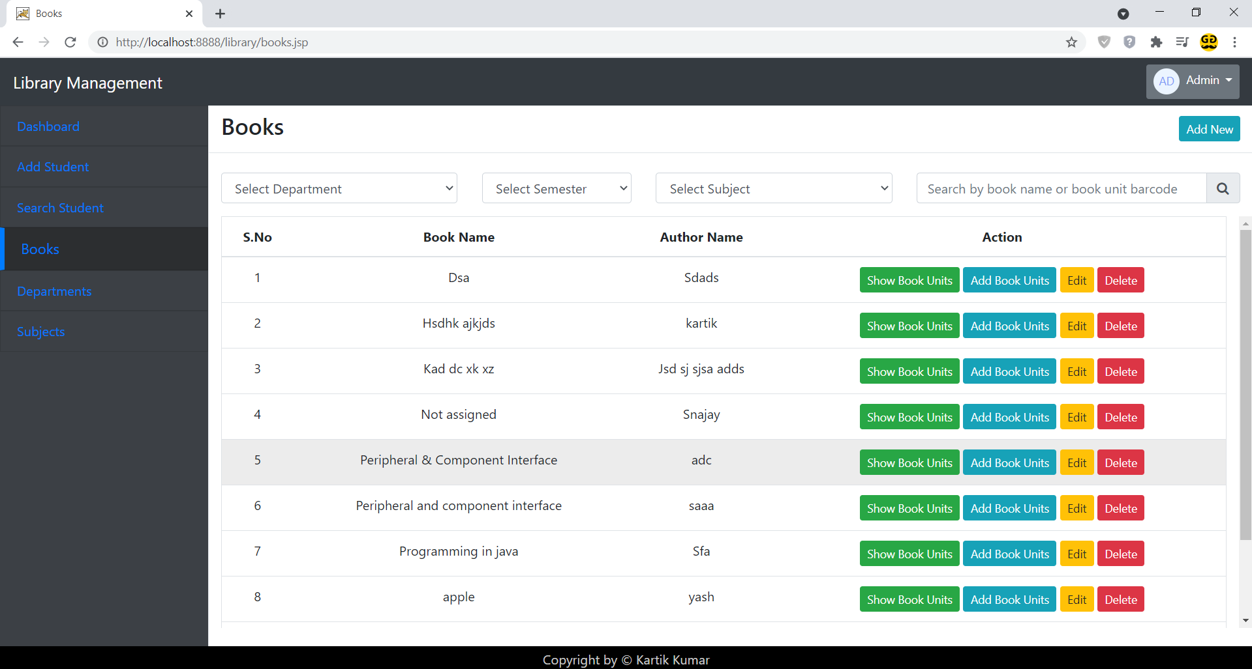

Add New Book Modal
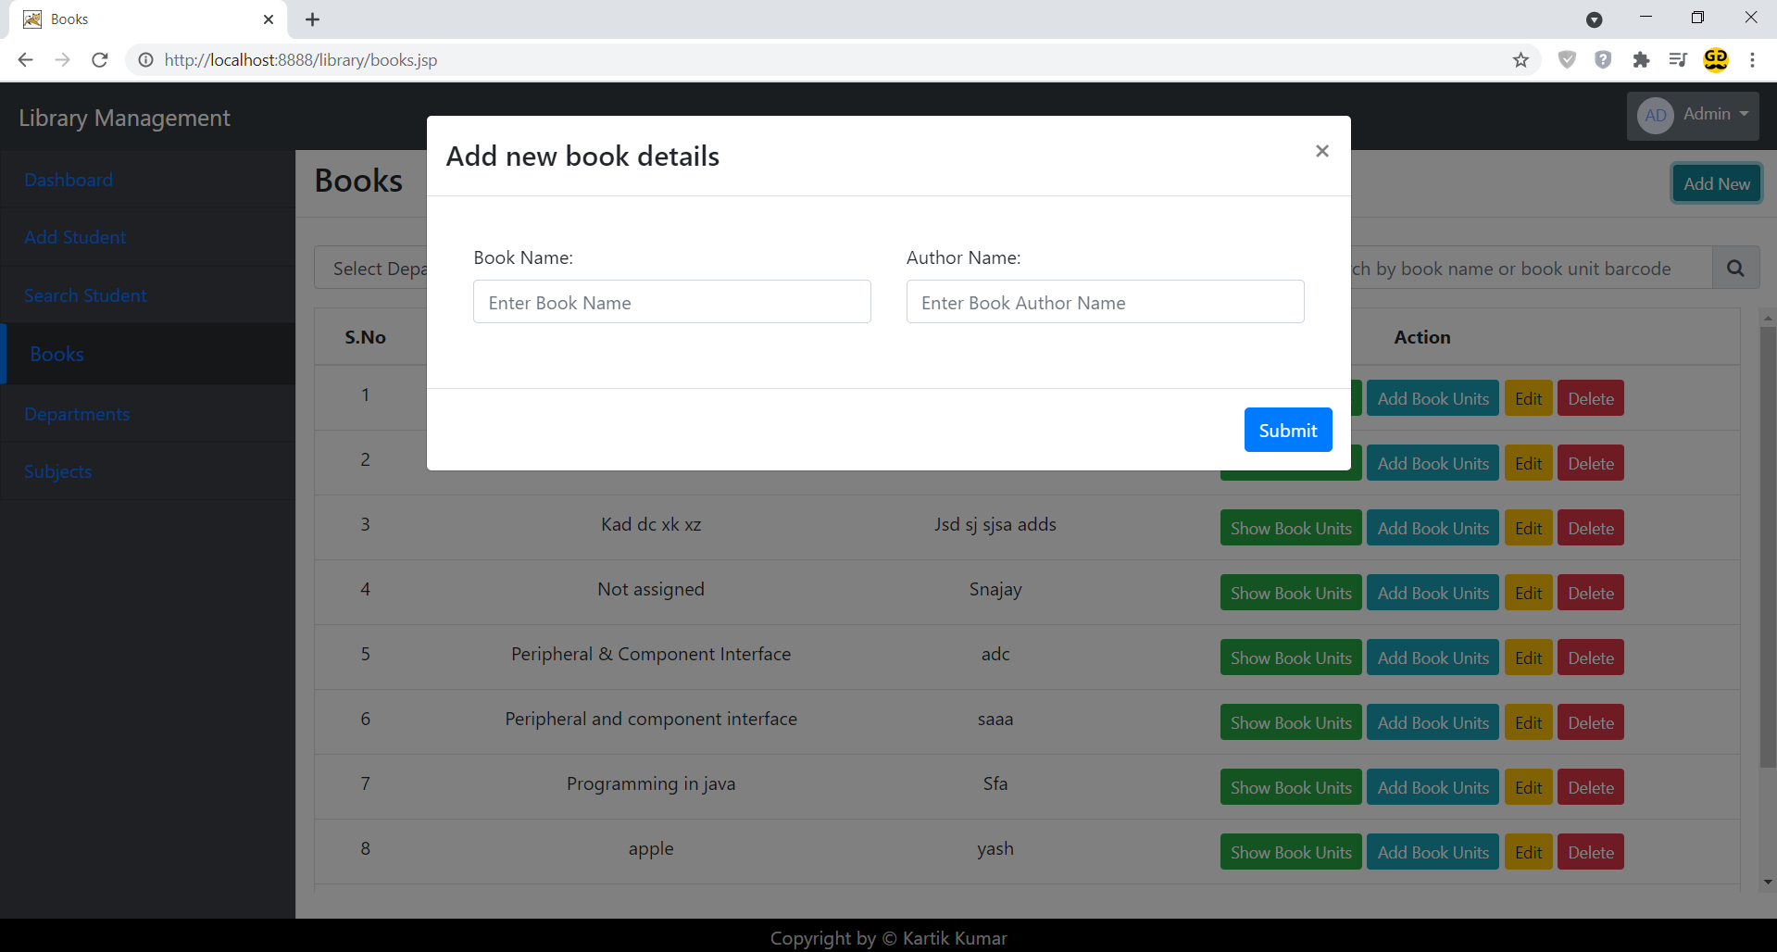
Add Book Units of Book Modal
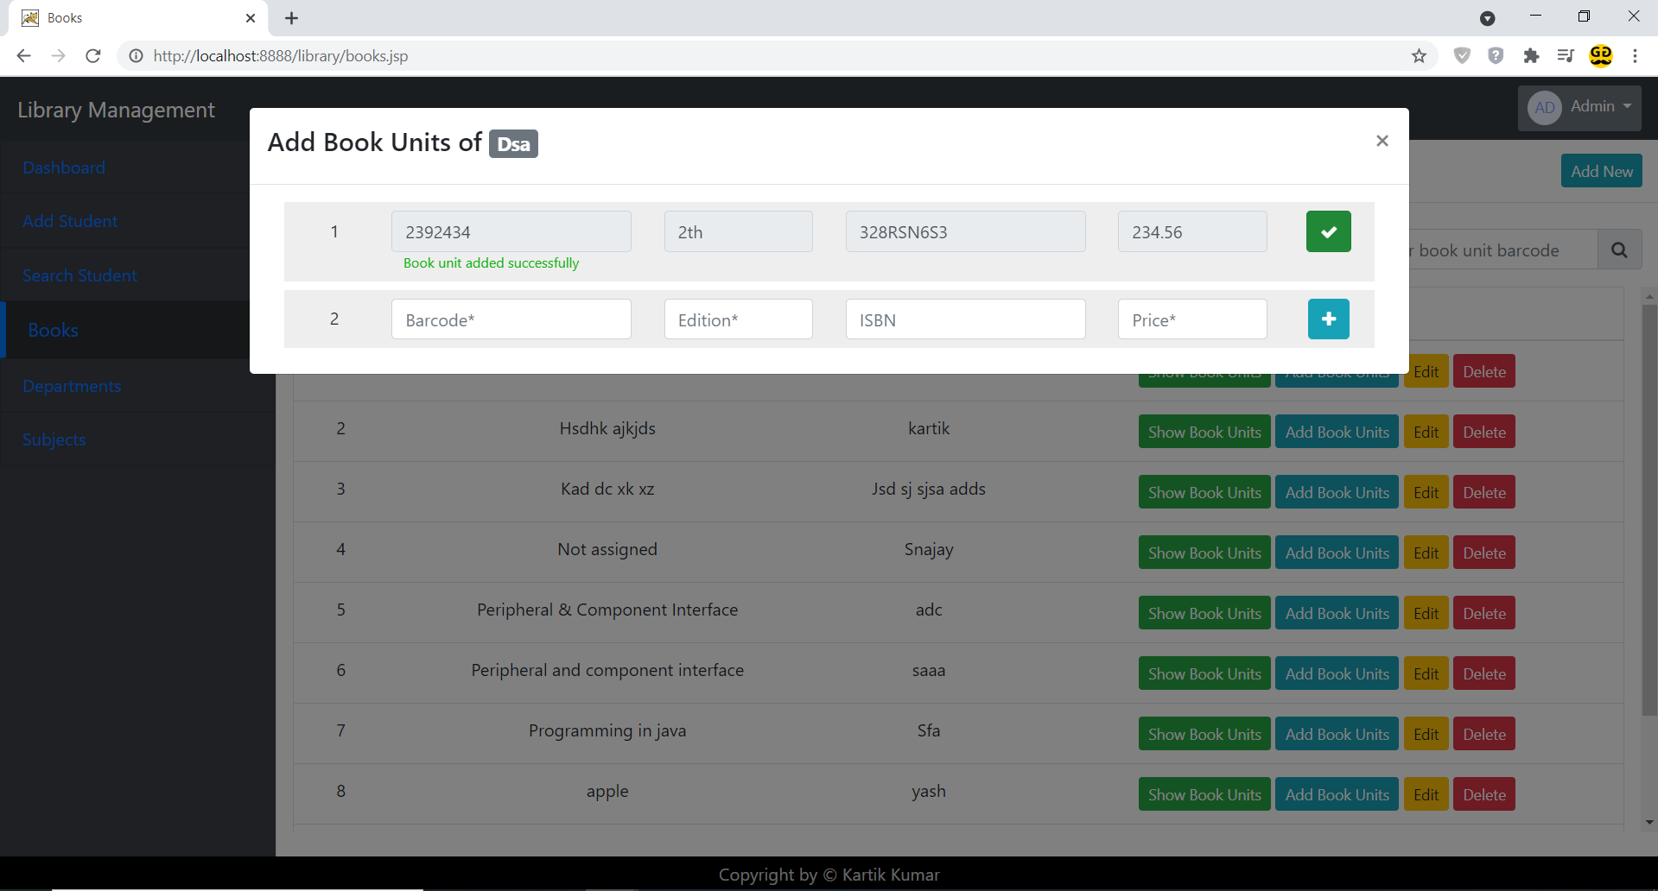
Show Book Unit of Book Modal
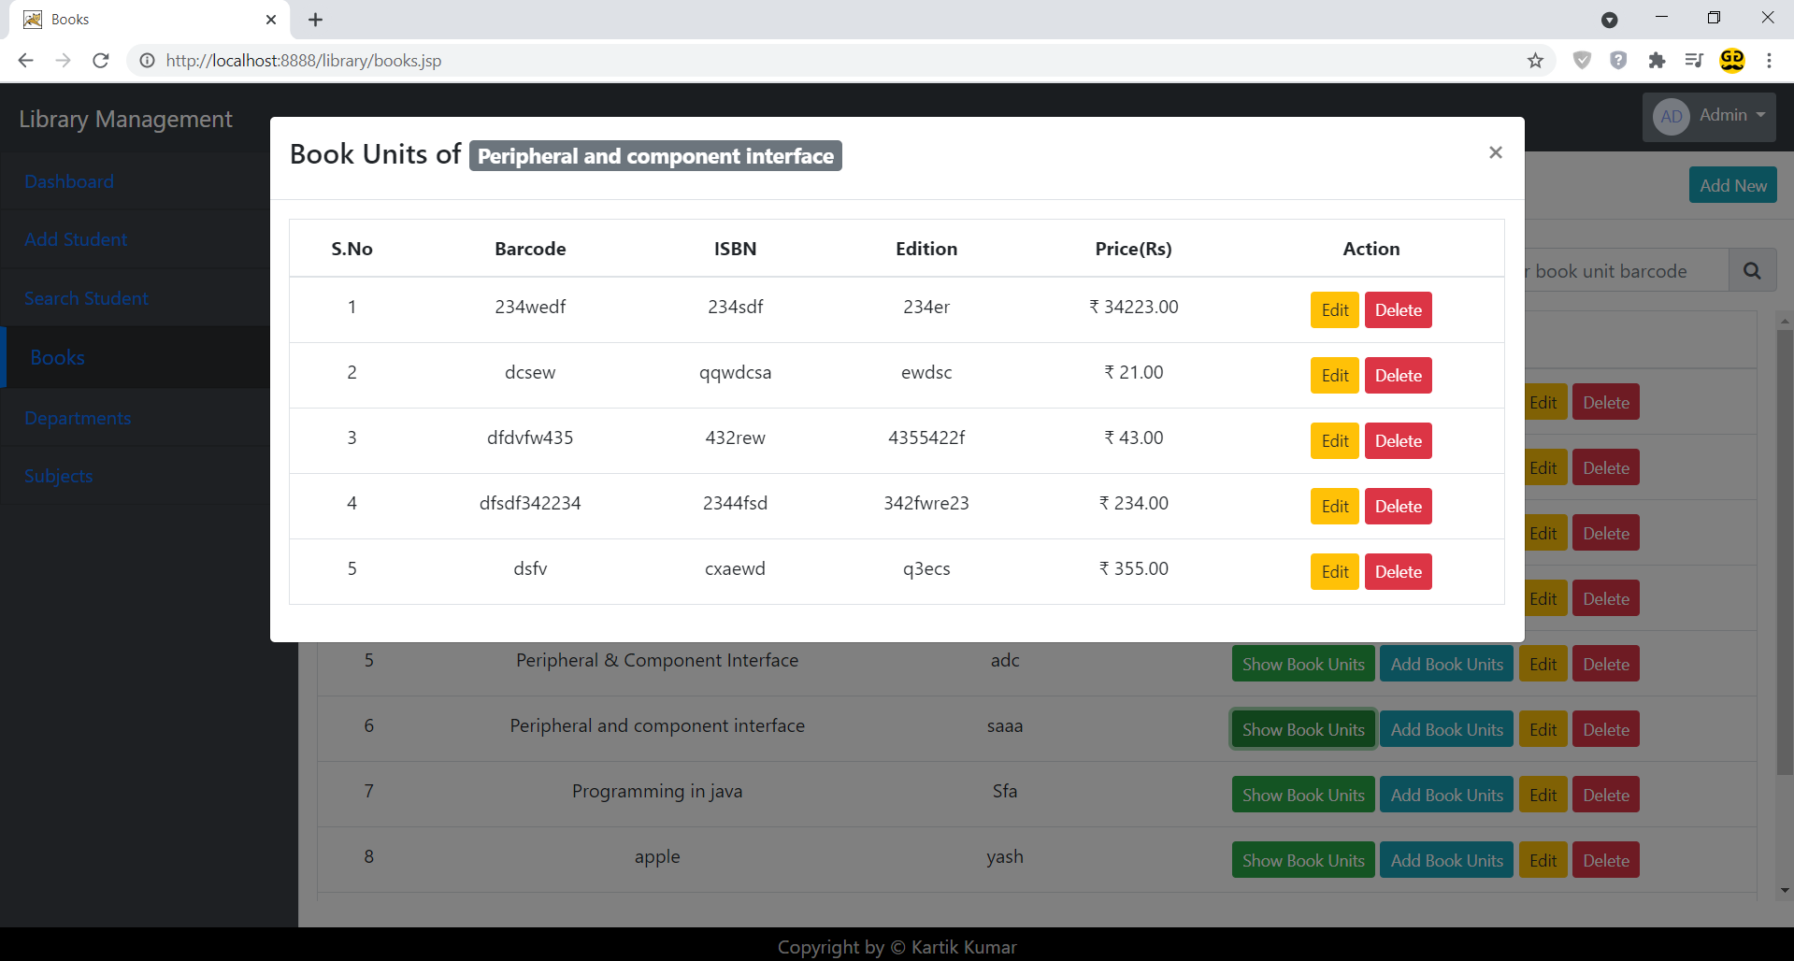
Department Screen
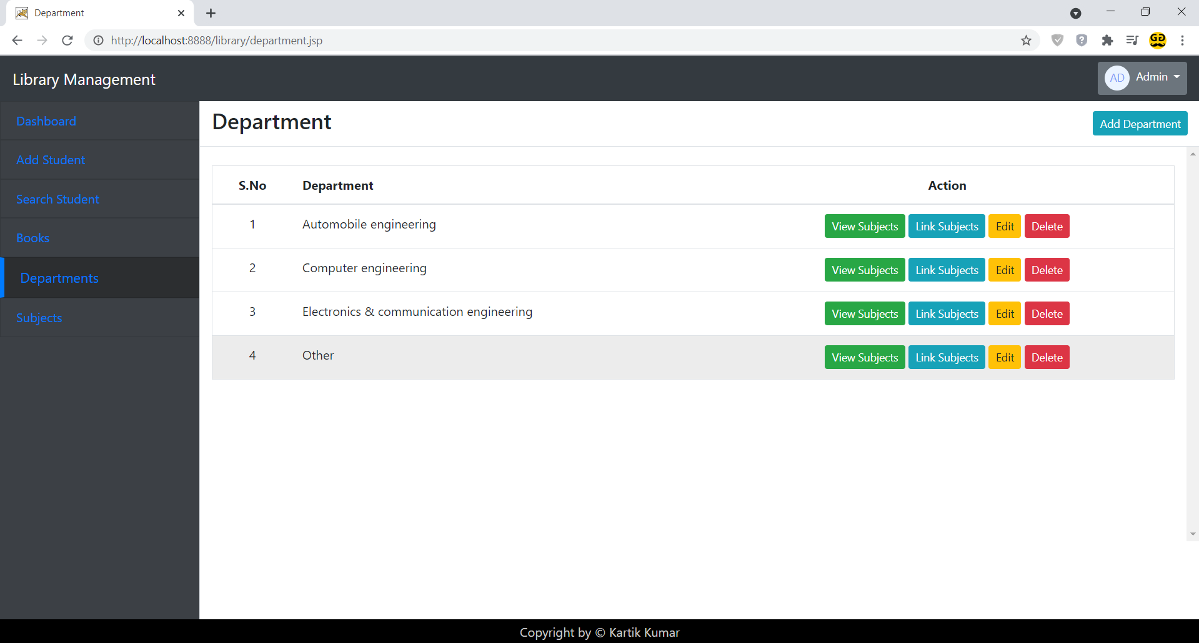
Add Department Modal
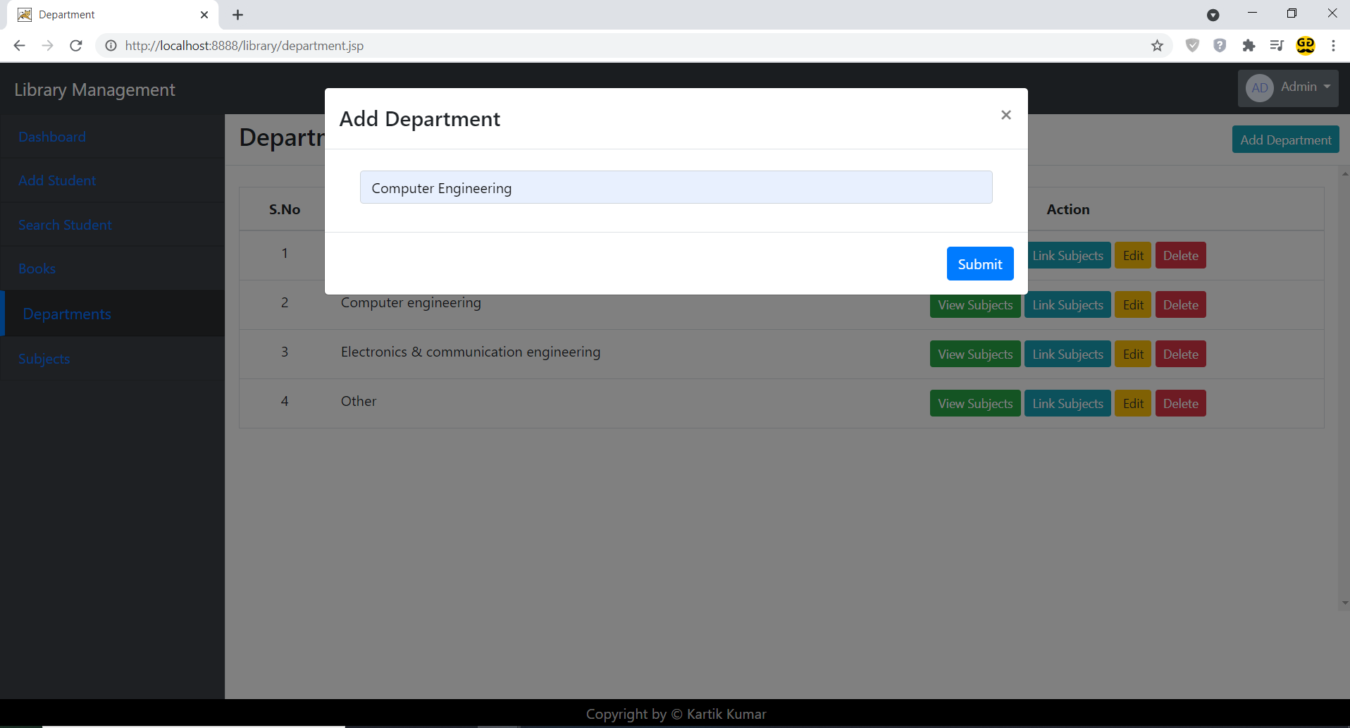
Link Subject to Semester in Department Modal
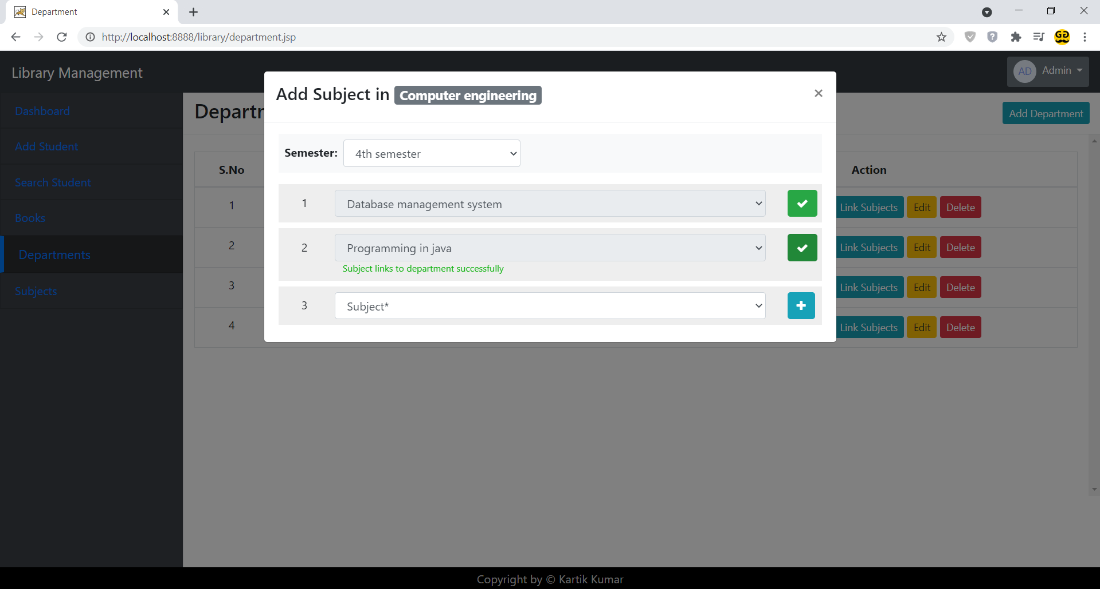
View Subject of Semester in Department Modal
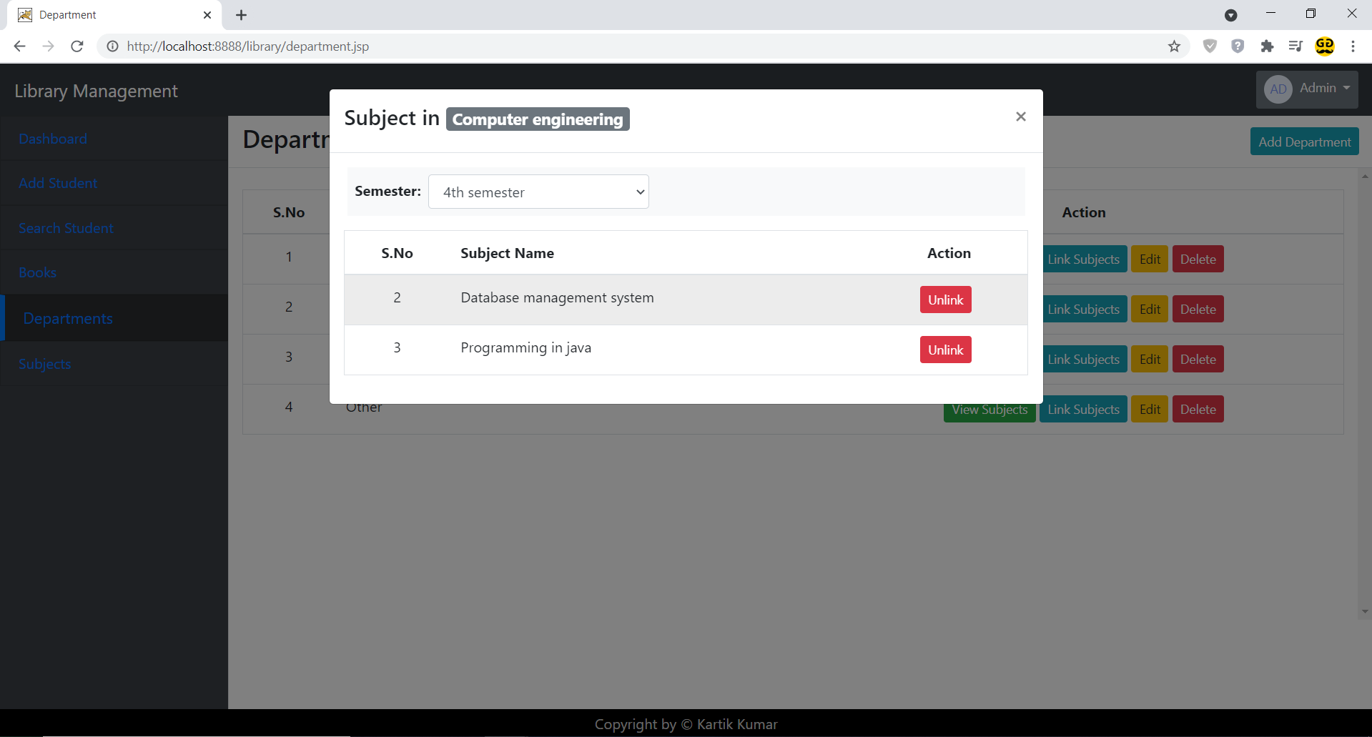
Subject Screen
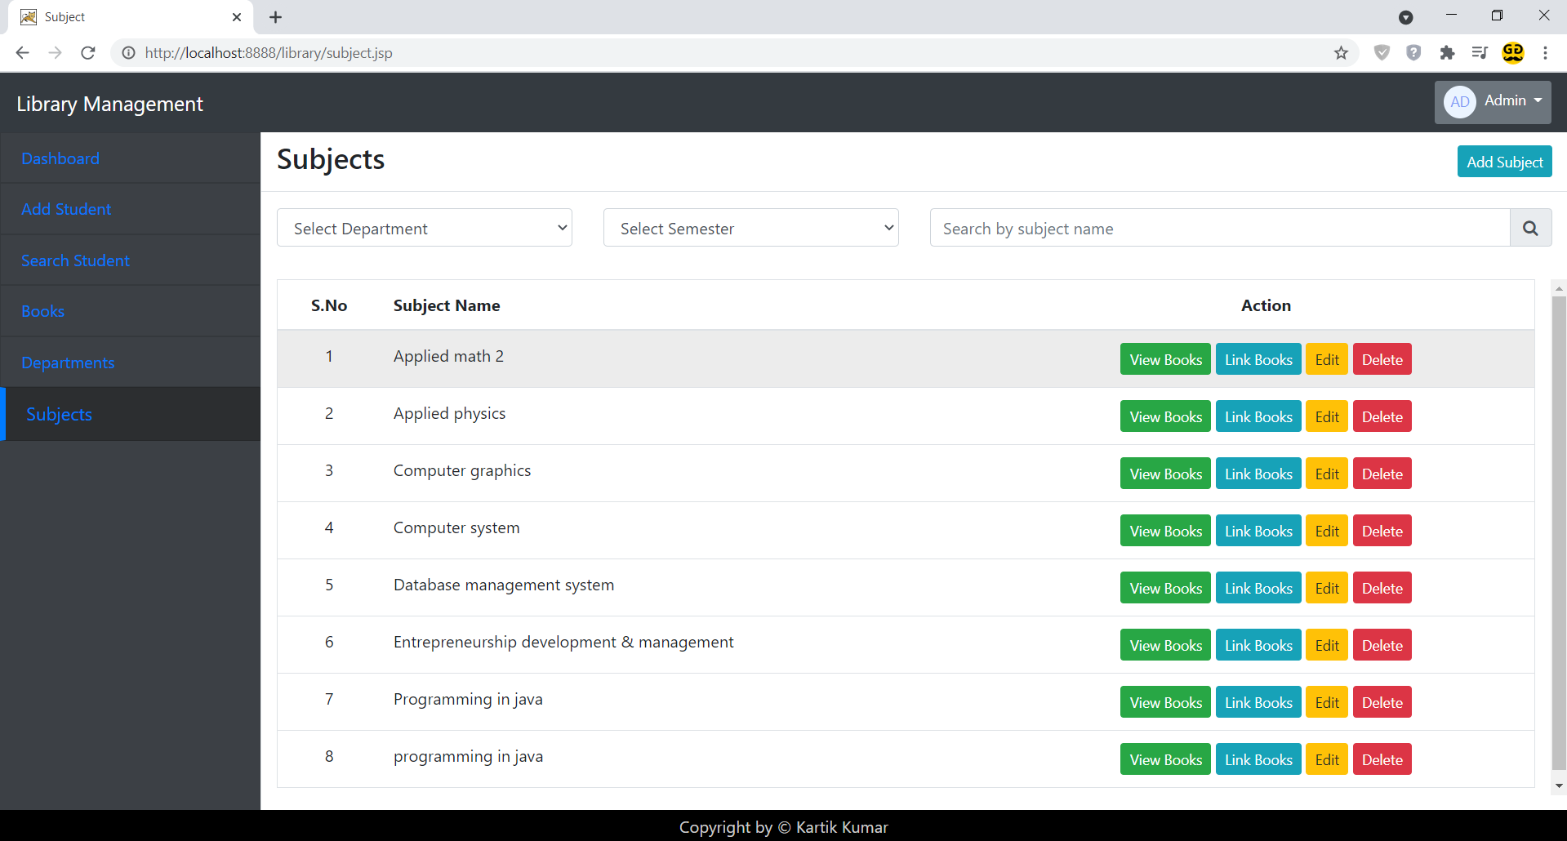
Add Subject Modal
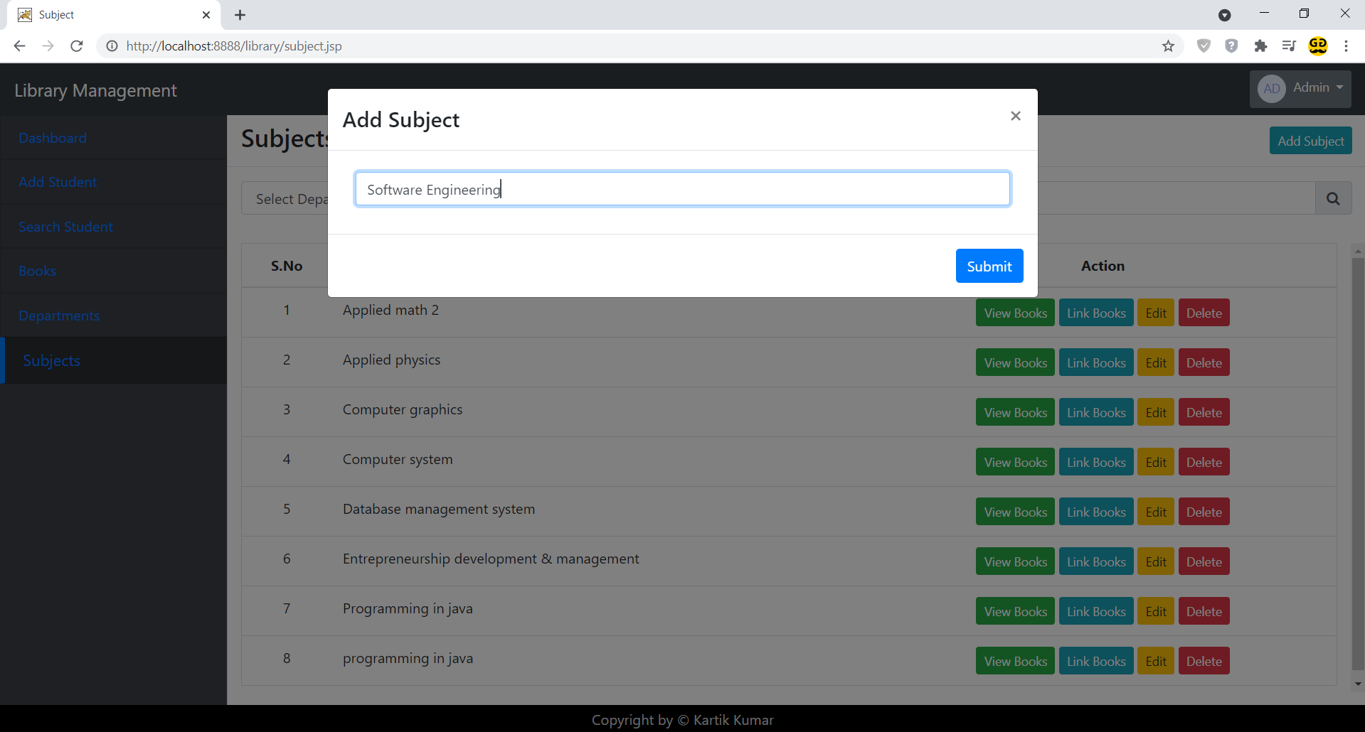
Link Books to Subject Modal
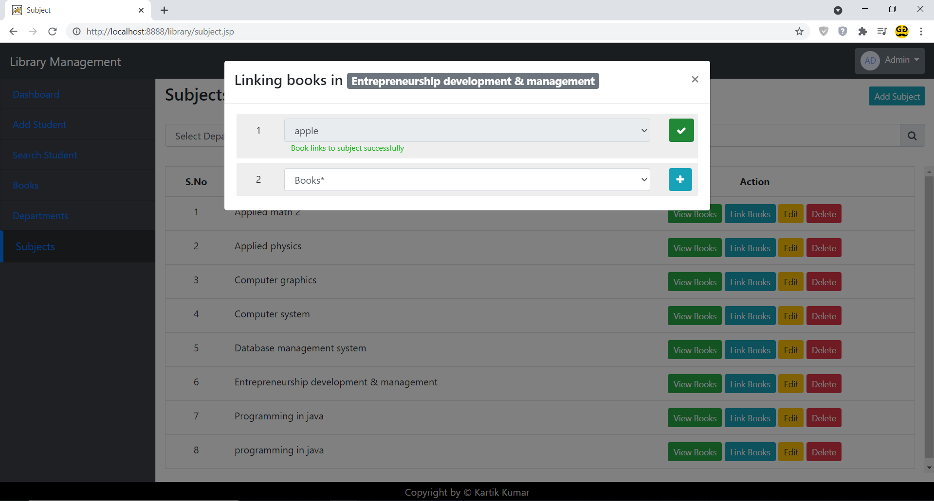
Link Books to Subject Modal
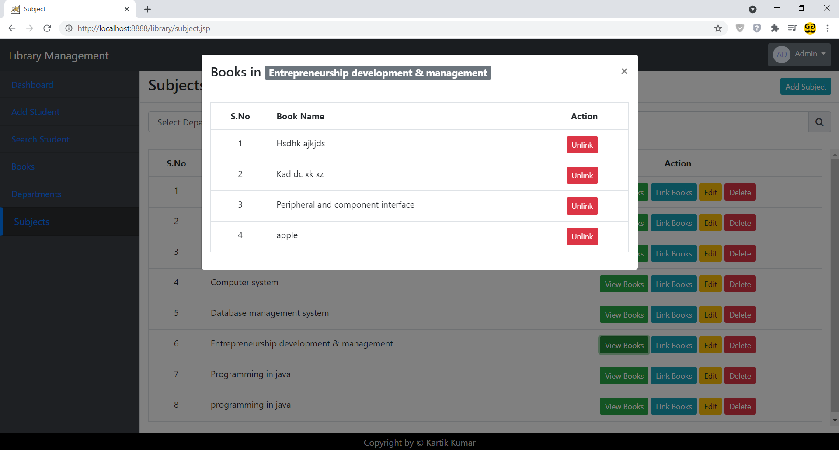
Send Reminder for Book Submission Screen
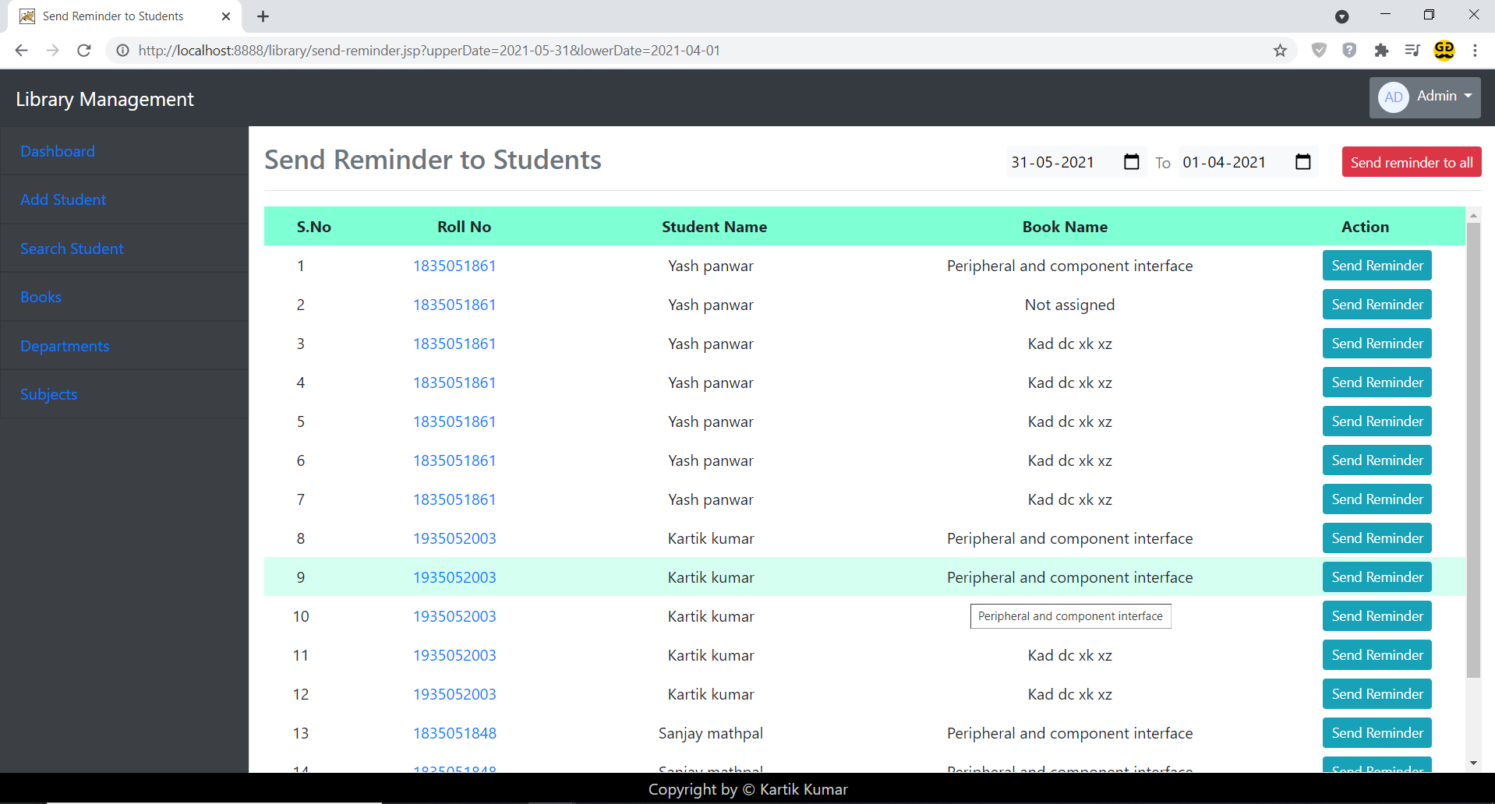
Conclusion
Our project is only a humble venture to satisfy the needs to manage their project work. Several user friendly coding have also adopted. This package shall prove to be a powerful package in satisfying all the requirements of the school. The objective of software planning is to provide a frame work that enables the manger to make reasonable estimates made within a limited time frame at the beginning of the software project and should be updated regularly as the project progresses.

At the end it is concluded that we have made effort on following points:
- A description of the background and context of the project and its relation to work already done in the area.
- Made statement of the aims and objectives of the project.
- The description of Purpose, Scope, and applicability.
- We define the problem on which we are working in the project.
- We describe the requirement Specifications of the system and the actions that can be done on these things.
- We understand the problem domain and produce a model of the system, which describes operations that can be performed on the system.
- We included features and operations in detail, including screen layouts.
- We designed user interface and security issues related to system.
- Finally, the system is implemented and tested according to test cases.

Future Scope
In a nutshell, it can be summarized that the future scope of the project circles around maintaining information regarding:
- We can add printer and barcode in future.
- We can give more advance software for Library Management System including more facilities.
- We will host the platform on online servers to make it accessible online.
- Integrate multiple load balancers to distribute the loads of the system.
- Implement the backup mechanism for taking backup of codebase and database on regular basis on different servers.
- We can create mobile app for student who can see assigned book and other information.
The above mentioned points are the enhancements which can be done to increase the applicability and usage of this project. Here we can maintain the records of Student and Books. Also, as it can be seen that now-a-days the players are versatile, i.e. so there is a scope for introducing a method to maintain the Library Management System. Enhancements can be done to maintain all the Student, Books, Book units, Assigned books and Submitted Books.
We have left all the options open so that if there is any other future requirement in the system by the user for the enhancement of the system then it is possible to implement them. In the last we would like to thanks all the persons involved in the development of the system directly or indirectly.

Limitation
Although I have put my best efforts to make the software flexible, easy to operate but limitations cannot be ruled out even by me. Though the software presents a broad range of options to its users some intricate options could not be covered into it; partly because of logistic and partly due to lack of sophistication. Paucity of time was also major constraint, thus it was not possible to make the software foolproof and dynamic. Lack of time also compelled me to ignore some part such as storing old result of the candidate etc.
Considerable efforts have made the software easy to operate even for the people not related to the field of computers but it is acknowledged that a layman may find it a bit problematic at the first instance. The user is provided help at each step for his convenience in working with the software.

List of limitations which is available in my Library Management System:

- Excel export has not been developed for Student, Books assigned, Book submitted, Books to some criticality.
- Not Suitable with barcode machine.
- Books won’t assign to teachers.

Bibliography
The following books were referred during the analysis and execution phase of the project.
Books Referred:
PROGRAMMING IN JAVA | ---E. BALAGURUSWAMY
BLACK BOOK HTML | ---WILEY DREAMTECH
JSP AND SERVLETS | ---MAHESH P. MATHA

Reference Link:
https://stackoverflow.com/
https://www.oracletutorial.com/
https://www.javatpoint.com/
https://www.youtube.com/watch?v=xve6QEgIR-0&list=PL0zysOflRCel5BSXoslpfDawe8FyyOSZb
https://www.w3schools.com/
https://www.w3adda.com/jsp-tutorial/jsp-sending-email
https://docs.oracle.com/en/database/oracle/oracle-database/19/index.html
https://api.jquery.com/jquery.ajax/
https://www.chartjs.org/
https://sweetalert2.github.io/

