U02 Server:

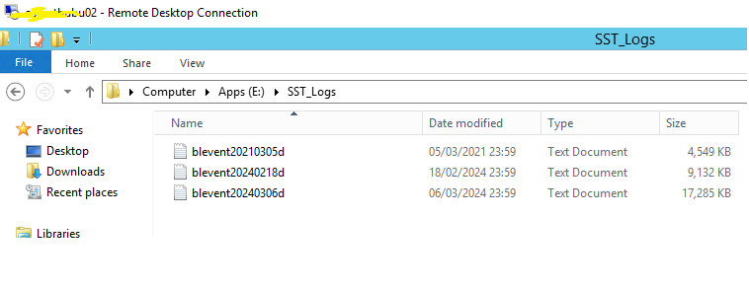

T01 server:

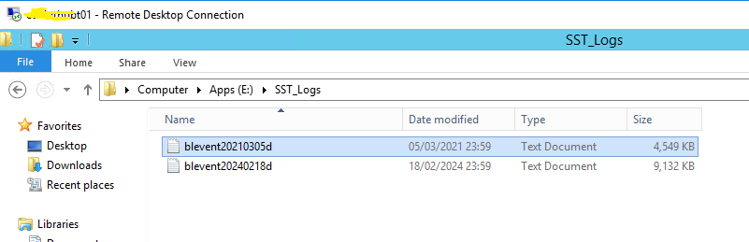

I can see only 2 log files are reading as below:

blevent20240306d.log this file available in U02 server but not reading/picking the log as per below screenshot filter.

