The Git Pull does not indicate if the pull finished successfully or not.
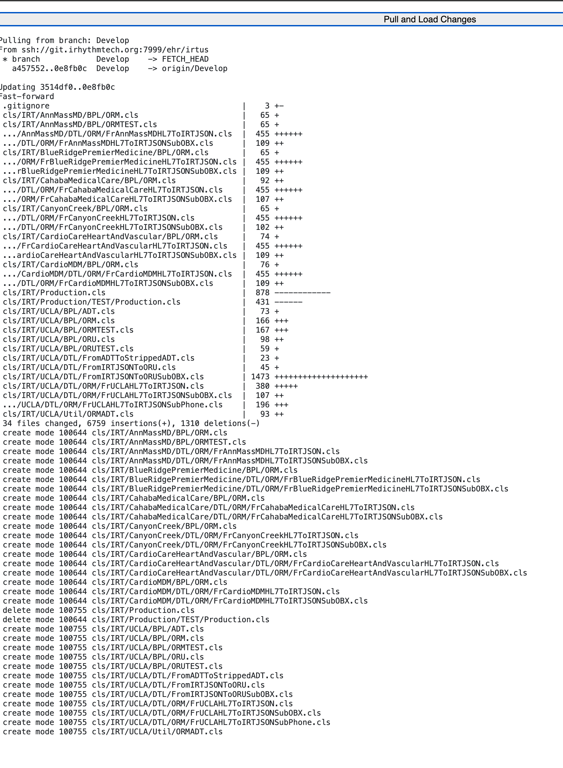

The classes get imported but uncompiled
