**Service**  
  
curl --location 'http://kong-serv.mangoocean-04c22221.eastus.azurecontainerapps.io/services' \

--header 'Content-Type: application/x-www-form-urlencoded' \

--data-urlencode 'name=betaservice' \

--data-urlencode 'host=52.188.135.212' \

--data-urlencode 'port=8081' \

--data-urlencode 'protocol=http'

**Route**

curl --location 'https://kong-serv.mangoocean-04c22221.eastus.azurecontainerapps.io/routes' \

--header 'Content-Type: application/x-www-form-urlencoded' \

--header 'Cookie: acaAffinity="f44401a1cbe4e7d3"; acaAffinity="40bef5822c12f9b0"' \

--data-urlencode 'name=betaservice' \

--data-urlencode 'service.id=63b93888-4c84-49f3-930d-429822933106' \

--data-urlencode 'paths%5B%5D=/betaservice'

**Consumer**  
curl --location 'https://kong-serv.mangoocean-04c22221.eastus.azurecontainerapps.io/consumers/' \

--header 'Content-Type: application/x-www-form-urlencoded' \

--header 'Cookie: acaAffinity="f44401a1cbe4e7d3"' \

--data-urlencode 'username=user123' \

--data-urlencode 'custom_id=user123'

**Oauth**

curl --location 'https://kong-serv.mangoocean-04c22221.eastus.azurecontainerapps.io/consumers/818d960f-4267-4430-9118-f1ef74400484/oauth2' \

--header 'Content-Type: application/x-www-form-urlencoded' \

--header 'Cookie: acaAffinity="40bef5822c12f9b0"' \

--data-urlencode 'name=Test Application' \

--data-urlencode 'redirect_uris=http://kong-serv.mangoocean-04c22221.eastus.azurecontainerapps.io:8000/betaservice/v1' \

--data-urlencode 'hash_secret=true'

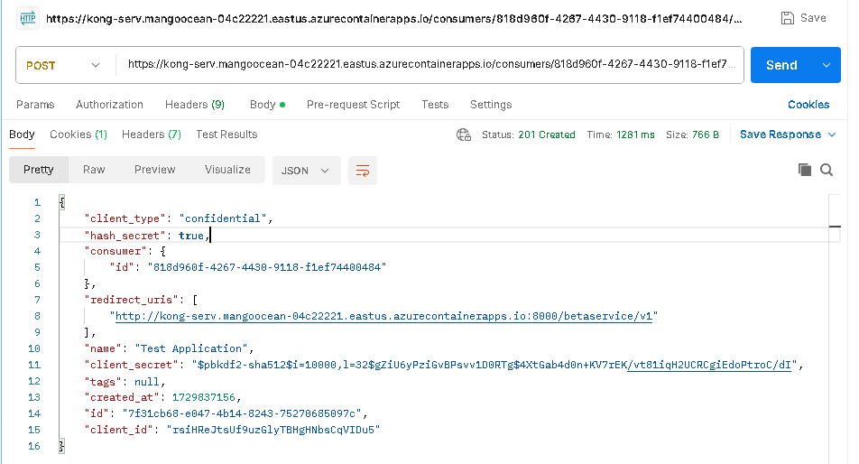

**Oauth/token**

curl --location 'https://kong-serv.mangoocean-04c22221.eastus.azurecontainerapps.io/betaservice/oauth2/token' \

--header 'Content-Type: application/json' \

--header 'Cookie: acaAffinity="40bef5822c12f9b0"' \

--data '{

"client_id": "rsiHReJtsUf9uzGlyTBHgHNbsCqVIDu5",

"client_secret": "$pbkdf2-sha512$i=10000,l=32$gZiU6yPziGvBPsvv1D0RTg$4XtGab4d0n+KV7rEK/vt81iqH2UCRCgiEdoPtroC/dI",

"grant_type": "client_credentials"

}'

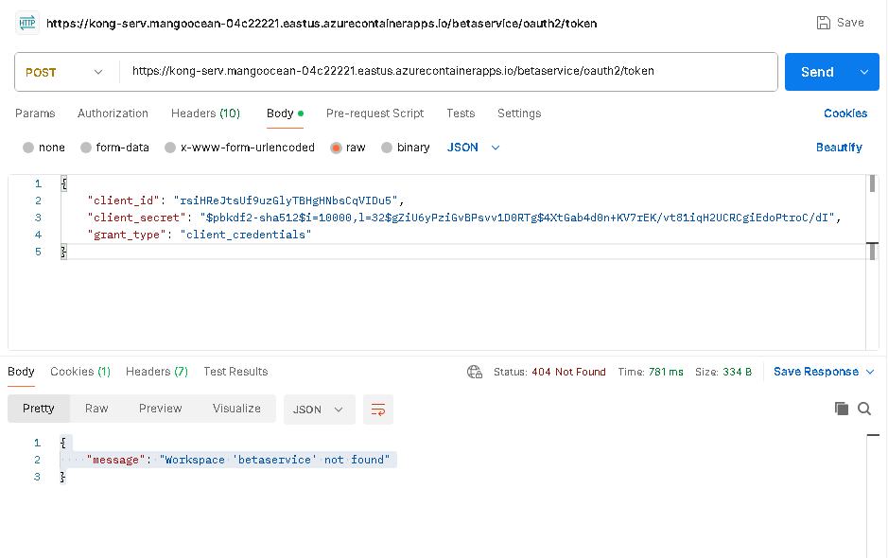

**Workspace**

curl --location 'https://kong-serv.mangoocean-04c22221.eastus.azurecontainerapps.io/workspaces' \

--header 'Content-Type: application/x-www-form-urlencoded' \

--header 'Cookie: acaAffinity="40bef5822c12f9b0"' \

--data-urlencode 'name=betaservice'

