Testing of 10969

Bug Reproduced in Internal



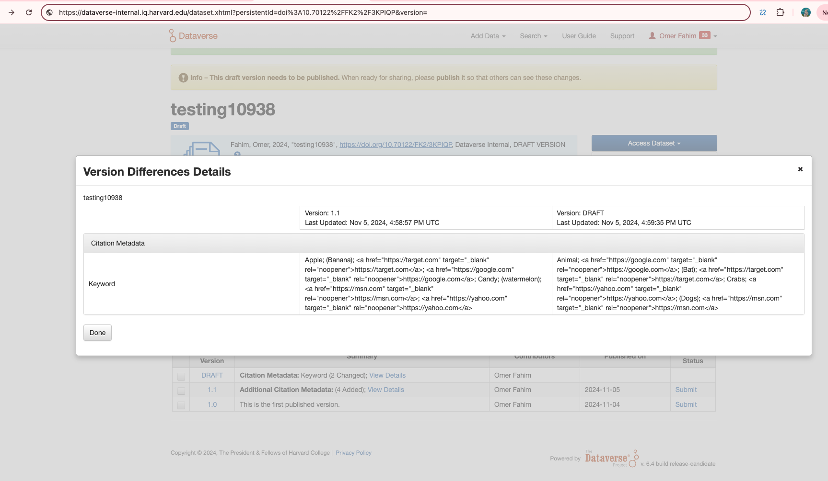

Testing Fix in Internal

