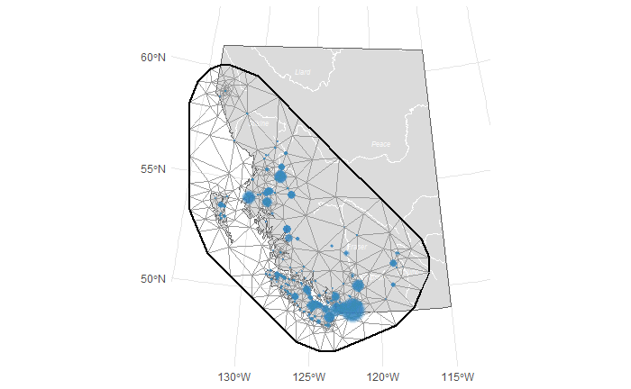

(SPDE mesh with 150 knots and a cutoff of 400)

**Data structure (some variables time-varying, others constant)**

|  |  |  |
| --- | --- | --- |
| **Variable** | **Type** | **Explanation** |
| X. Days | Response | Total number angler days (per year and river) from the STQ. |
| Stocking | Time-Varying | Proportion of stocked fish in total catch from the STQ. |
| Classified waters | Constant (binary) | The classified waters of B.C. are 52 highly productive trout streams that require special management due to popularity, ecological significance. an |
| Ecotype | Constant | Ecotype is derived from the STQ and included as a categorical covariate as either summer (S), winter (W) or mixed stocks (SW). |
| Area | Constant (scaled) | Stream area queried from the Freshwater Atlas, calculated as the area of the stream polygon in square meters. |
| Population density | Constant (scaled) | Survey data from the Center for International Earth Science Information Network’s (CIESIN) was queried to get estimates of human population (number of persons per pixel) consistent with national census and population registers for the year 2000. Population density was calculated by creating a 50km buffer around each lat/lon point for a given stream, and calculating the population density within that buffered area. This provides a relative index of how densely populated an area is around a given stream. |
| Average CPUE | Spatially varying | Average catch-per-unit-effort was calculated as the total number of fish caught divided by the total number of angler days (by year and stream). A three year rolling average was calculated. |
| Year | Time-Varying | Survey spans from April 1st of one year to March 31st of the following year. The first year of the licensing season was selected (e.g., 2018 would be selected for the 2018-2019 season) to facilitate the comparison with the fisheries-independent data. |

**Model with random intercept of stream**

**Model with random intercept of Area**

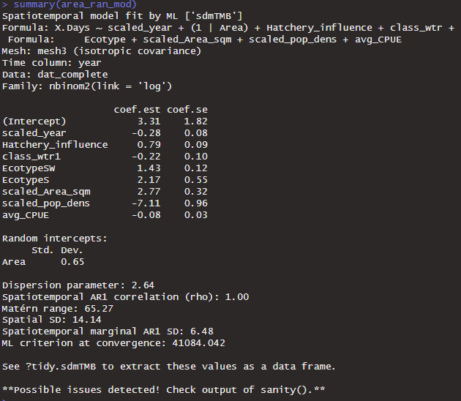

**Model without random intercept**

