Embedded in ‘bisonw-linux-amd64-v1.0.2’

bisonw v1.0.2

Embedded: entry.js
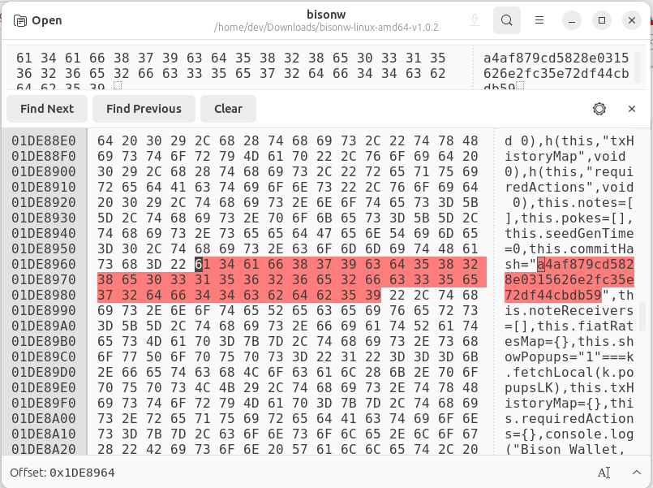

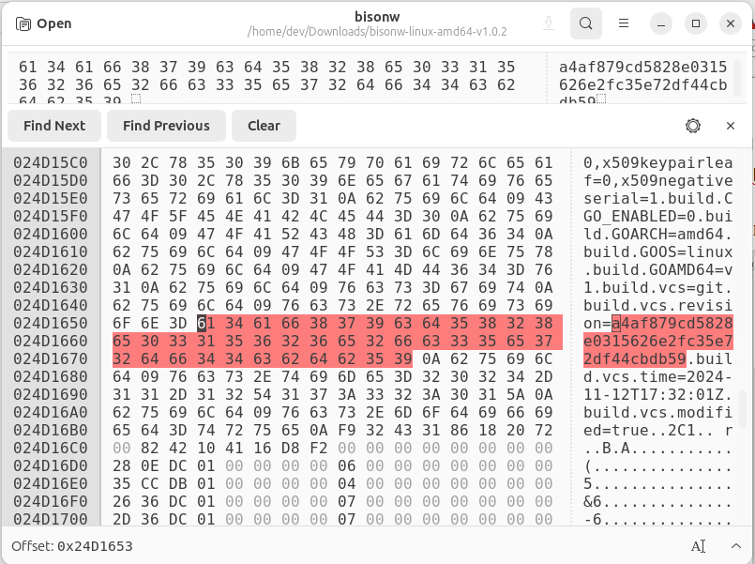
Embedded: vcs.revision

$ go version -m -v bisonw
bisonw: go1.23.0
path decred.org/dcrdex/client/cmd/bisonw
.
.
build GOARCH=amd64
build GOOS=linux
build GOAMD64=v1
build vcs=git
build vcs.revision=a4af879cd5828e0315626e2fc35e72df44cbdb59
build vcs.time=2024-11-12T17:32:01Z
build vcs.modified=true

Also checked for:
- bisonw-windows-amd64-v1.0.2
- bisonw-darwin-amd64-v1.0.2

build vcs.revision=a4af879cd5828e0315626e2fc35e72df44cbdb59

