1. When the focus is on the “Font” menu, use down arrow ( you will see “Sans-seriff” has a check mark next to it) and go the last submenu item “Fantasy” and select enter. The Font changes accordingly. Select tab to go the next focusable item. The whole menubar is missing now.

Please see the screenshot #1.

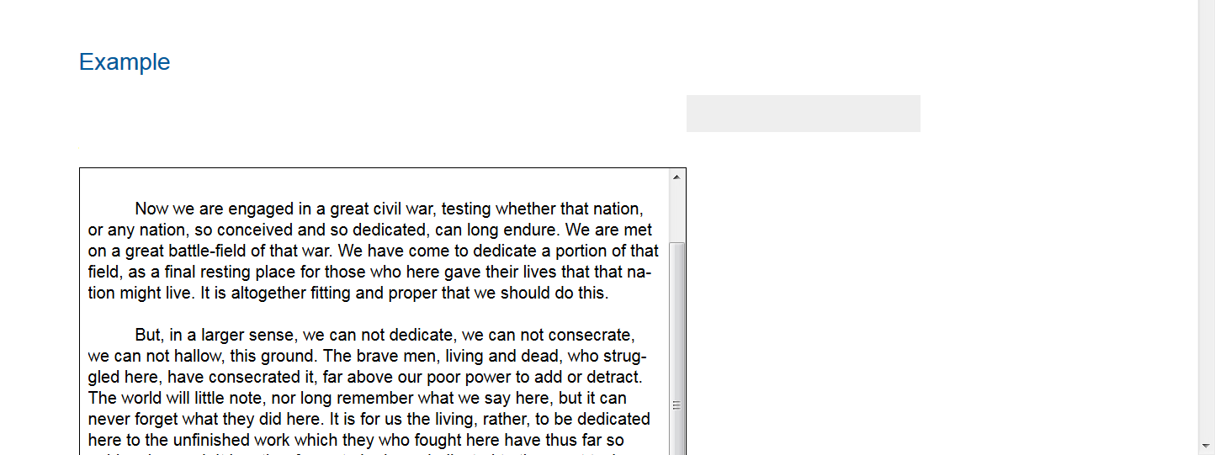

2)When I selected Fantasy, now I go to the next item (Style/Color) in the menubar by clicking the right arrow.

Then I will go back to the previous item(Font) to see my selection and none of them have a checkmark next to it.

Screen reader NVDA in FF browser is not announcing that the different font is selected (on selecting enter) and when I go back to that font type by using up and down arrow, NVDA is reading the font type is not checked but the font is changed in the tab panel according to the selection made.

Please see the attachment #2

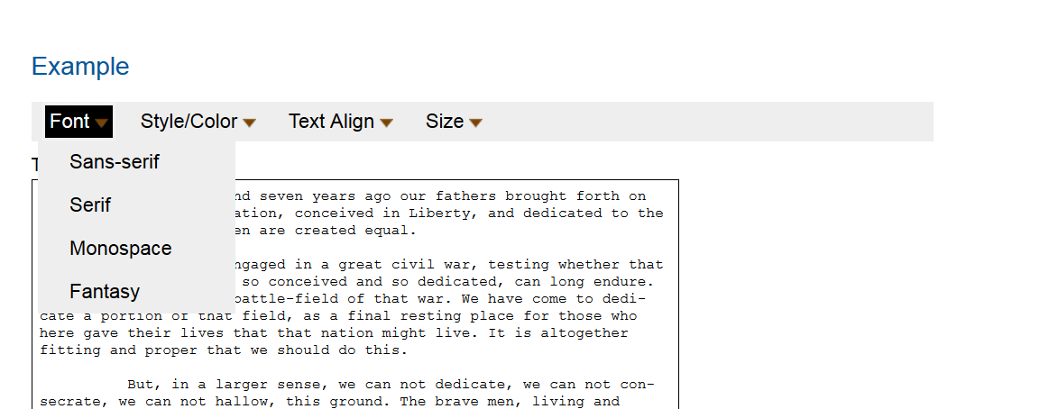

3)

In Style/color menu. Upon selecting only first two submenu items got check mark next to them. Not for the remaining selections.

Please see screen shot#3

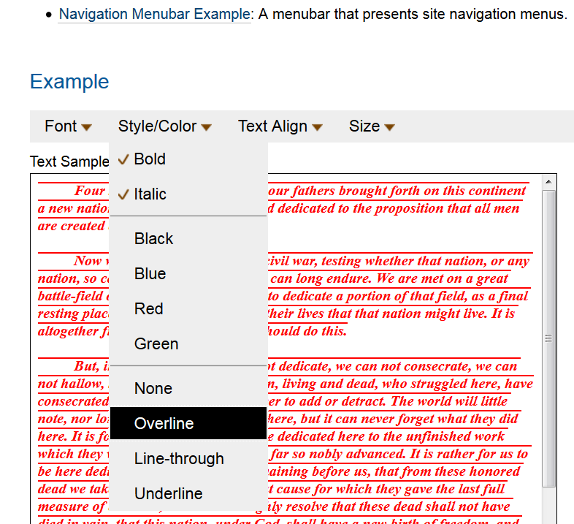

4) Same issue exit for all submenu items for the “Text Align”

