# WMDS Validation Report

Topic: **Geopositioning Method**

Issue(s) addressed (URLs): <https://github.com/wmo-im/wmds/issues/162>

Assigned (full name, e-mail): Karl Monnik, [karl.monnik@bom.gov.au](mailto:karl.monnik@bom.gov.au)

Experts involved (full name, e-mail): Charles Fierz, [fierz@slf.ch](mailto:fierz@slf.ch)

Jörg Klausen, [joerg.klausen@meteoswiss.ch](mailto:joerg.klausen@meteoswiss.ch)

Tim Oakley, [TOakley@wmo.int](mailto:TOakley@wmo.int)

## Document History

|  |  |  |  |  |
| --- | --- | --- | --- | --- |
| Status | Date | Version | Author | Comments |
| In Preparation | 2020-05-19 | 0.1 | K Monnik | Initial draft/proposal |
| Under Review | 2020-05-20 | 0.2 | K Monnik | Following discussions Teleconference #11 |
| Under Review |  |  |  |  |
| Under Review |  |  |  |  |
| Under Review |  |  |  |  |
| Under Review |  |  |  |  |
| Under Review |  |  |  |  |
| Under Review |  |  |  |  |

## Background

At present, and more likely in the future, one is often faced with instruments using more than one Global Navigation Satellite System (GNSS) to determine the coordinates of a point. Unfortunately, this is not reflected in Table 11-01 (see attached).

Proposed to add an additional row to the table called GNSS (multiple).

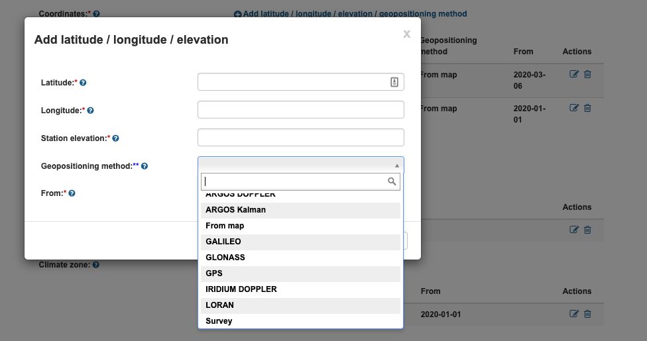

The WMO Codes Registry has the following options: Register: Coordinates source/service

<http://codes.wmo.int/wmdr/GeopositioningMethod>

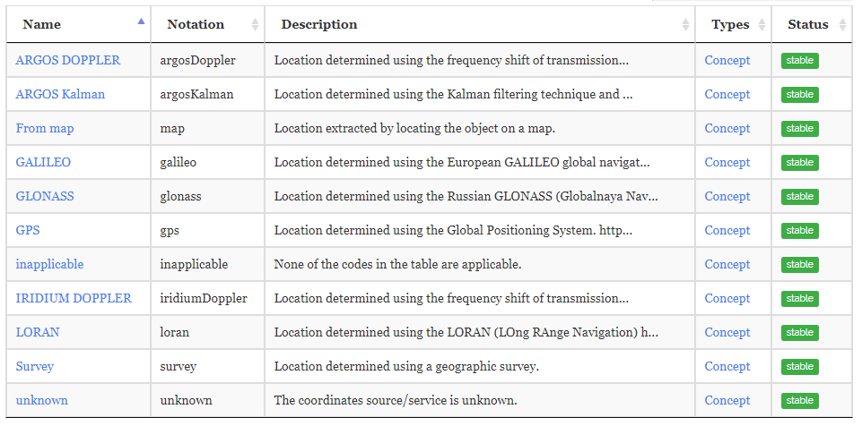

## Proposal

Metadata that requires a **GeoPositioning method** should allow >1 method to be selected. Multiple **GeoPositioning Methods** should allow different start and end dates.

## Considerations

At Teleconference #11, it was cautioned that using GNSS (multiple) could reduce the quality of the metadata, as the types of GNSS systems used would be unknown.

Alternatively, >1 Global Positioning method should be allowed. The impact of this on the WMDR and OSCAR/Surface needs to be tested.

## Conclusion and Recommendation

It is recommended that >=1 instances of **Coordinates source/service** table in the WMO Codes Registry be allowed. <http://codes.wmo.int/wmdr/GeopositioningMethod>